Getting Started With Riverdi Displays: CAN-FD Tutotial


This guide considers the usage of two Riverdi displays to demonstrates the usage of CAN-FD bus of STM32 Embedded Displays from Riverdi. The guide shall use two Riverdi displays as following:
- Riverdi 10.1” which will be the dashboard of EV where the battery level and charging state is being display and faults within the battery.
- Riverdi 7.0 which will act as battery simulator of EV where it shows battery level and state, also in case there is communication lost with the other display.

The guide shall cover the following topics:
- What is CAN-FD.
- Developing the UI for Riverdi 10.1 display.
- Developing the UI for Riverdi 7.0 display.
- CAN-FD Confoguration.
- FreeRTOS configuration for Riverdi 10.1. display.
- FreeRTOS configuration for Riverdi 7.0 display.
- Firmware development for Riverdi 10.1 display.
- Firmware development for Riverdi 7.0 display.
- Riverdi displays connection.
- Results.

1. What is CAN-FD:

CAN-FD which stands for Controller Area Network Flexible Data Rate is the extension of the original CAN that was specified in ISO 11898-1 which has been developed by BOSCH. The CAN-FD developed in 2011 and released in 2012 to meet the demands of increased data transfer rate for automotive by up to 5 times (from 1Mbps to 5Mpbs) and larger payload for the data.

1.1 Data Frame of CAN-FD:

Figure 1 shows the data frame of CAN-FD.
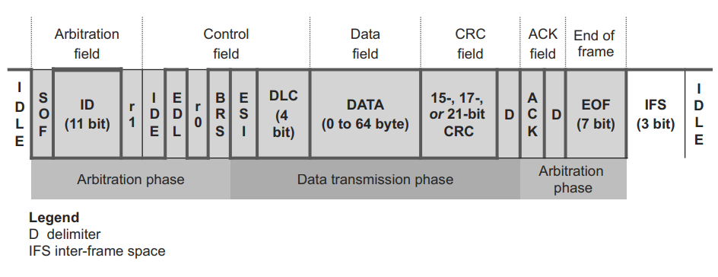Figure 1: CAN-FD Data Frame (source).
The data frame has the following:
- Arbitration Phase:
The Arbitration phase has the following:
  - Start of Frame (SOF): Which is indicates the start of the data by sending dominant bit (LOW) by the send. This is listened by all the nodes to synchronize their internal clock.
  - ID, Which is Identifier (11/29 bits) for the node identification.
  - R0 and R1 are reserved bits of 0 and 1 respectively for future usage.
  - IDE for identifier extension bit to switch between 11 and 29 when set to 0 and 1 respectively.
  - BRS which stands for bit rate switch which allows the arbitration phase to be transmitted on one baud rate while the data on other baud rate. In this guide, this feature in not considered.
- Data Transmission Phase:
The data transmission phase has the following:
  - Error State Indicator (ESI): Which handle the error state for the transmitting node which can be either error-active state or error-passive state. When ESI is set to 0, it indicates that the node is in error-active state, which indicates that node is active and participate in the communication and can signal for error using error frames. When the ESI bit is set to 1, it indicates the node is in error-passive state which the node has experienced errors and can no longer participate in the communication.
  - Data Length Code (DLC): which indicate the length of the data to be transmitted from the node (0 to 64 bytes).
  - Cyclic Redundancy Check (CRC): which is used to ensure the correctness and integrity of the transmitted messages.
  - D which is a counter for the received message for so that the CRC can be calculated correctly.
- Arbitration Phase:
The second arbitration phase has the following:
  - Acknowledgment (ACK): which indicates that at least one node has successfully received the message.
  - End of Frame (EOF), this field uses 7-bit to ensure a proper termination of the transmitted message.
  - Interframe Space (IFS) which ensure a proper timing and separation between consecutive transmission.

2. Developing UI for Riverdi 10.1”:

First step, download and install TouchGFX from ST website.
- TouchGFX website here.
- Installing TouchGFX video from ST here.
- Also, install STM32CubeProgrammer from here.
- Finally, download this external loader file and copy it to the following path:
C:\Program Files\STMicroelectronics\STM32Cube\STM32CubeProgrammer\bin\ExternalLoader or path where you have CubeProgrammer installed.

After installing the TouchGFX, Open TouchGFX.
To create New project based on Riverdi 10.1, follow the following steps:

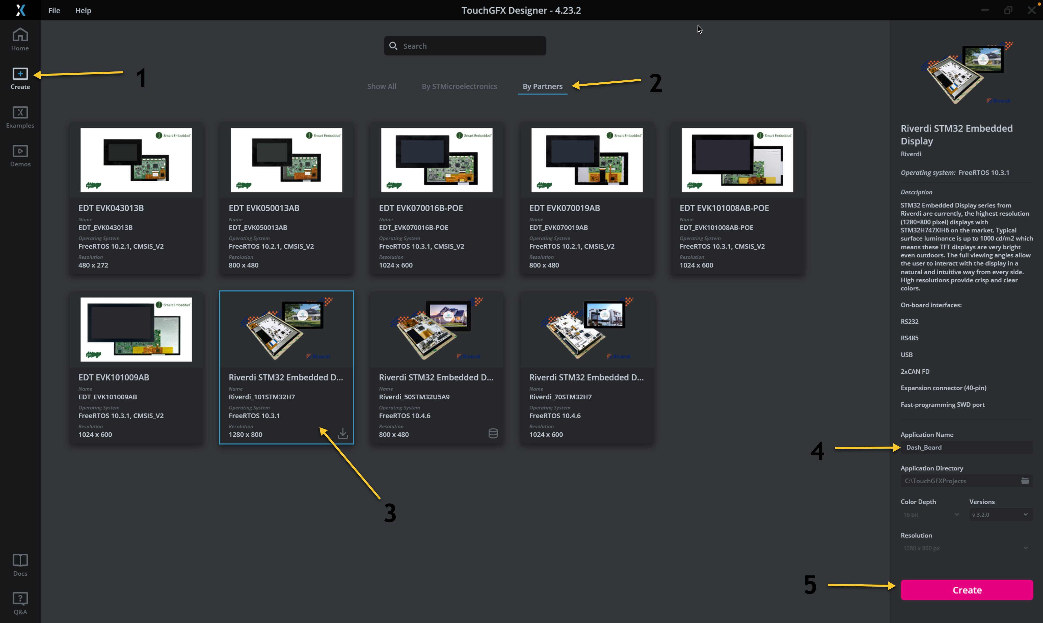
- From left side, select Create.
- Go to By Partners tab.
- Select Riverdi_101STM32H7.
- Give the project a name.
- Click on Create.
Once the project is created, you are welcomed with this blank project as shown below.
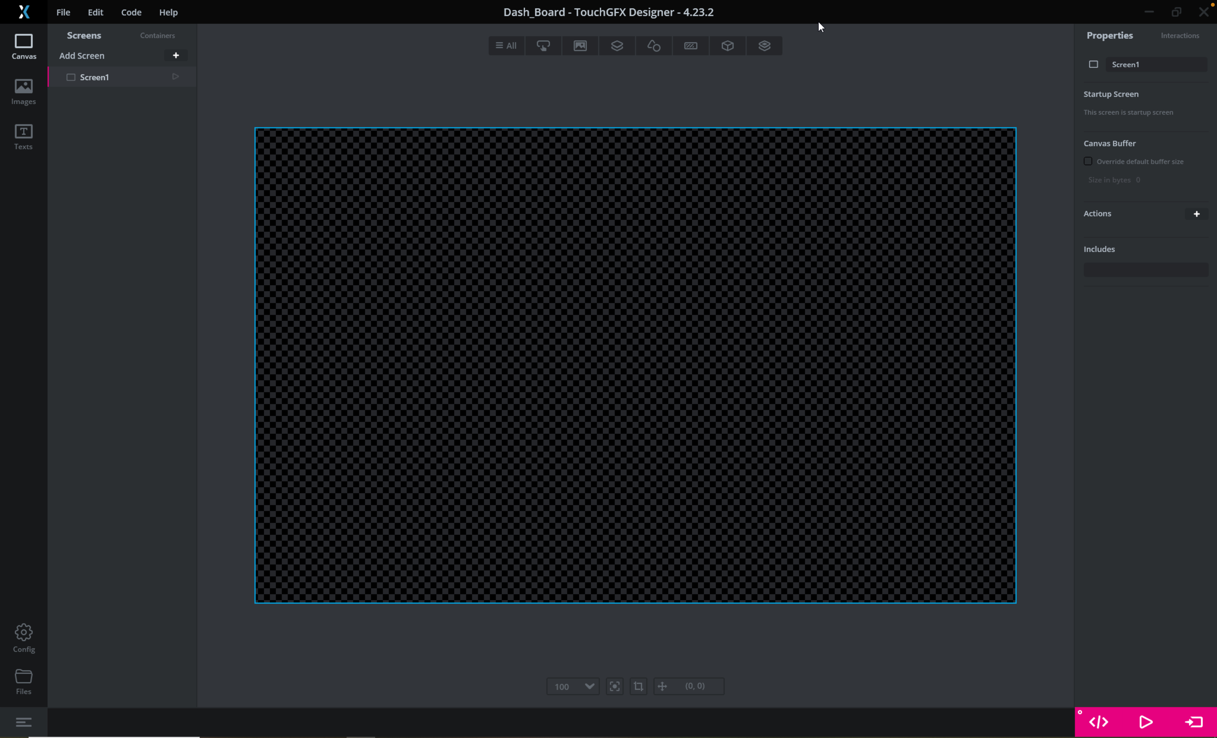
Now, from the left side, press on the images tab.
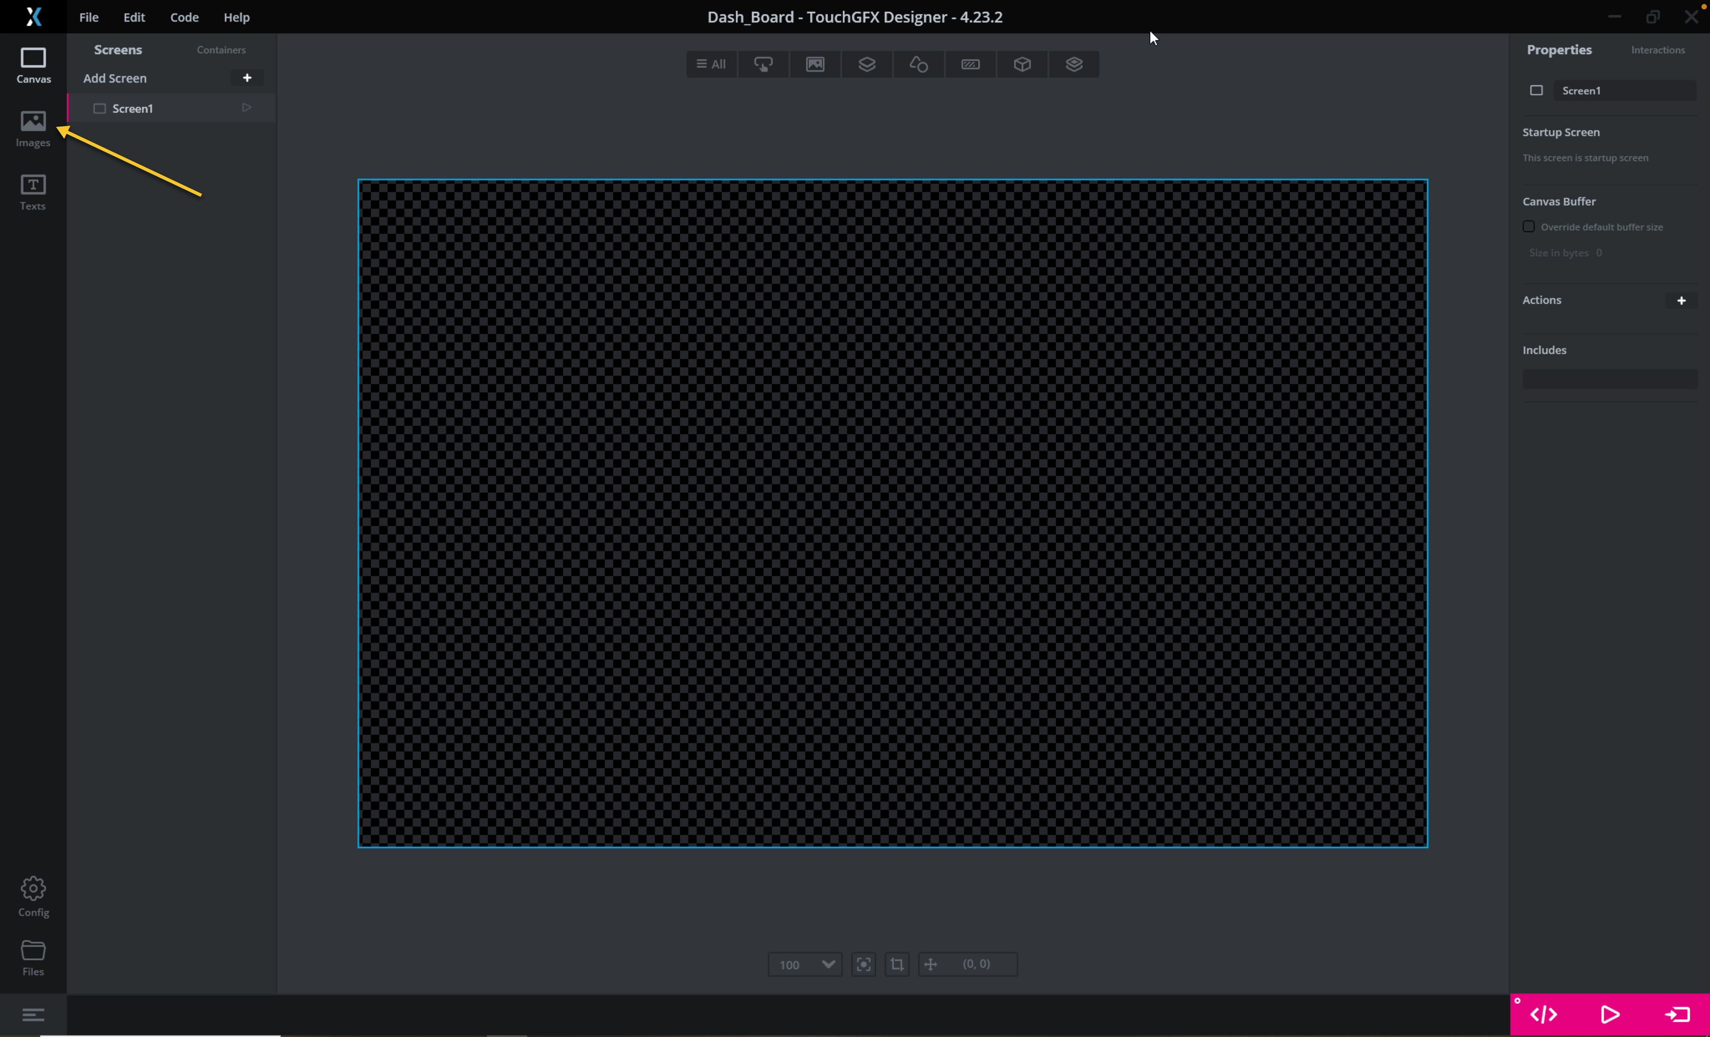
Head to this github repository to get the images for the UI.

Next press on the + sign as shown in the figure below:
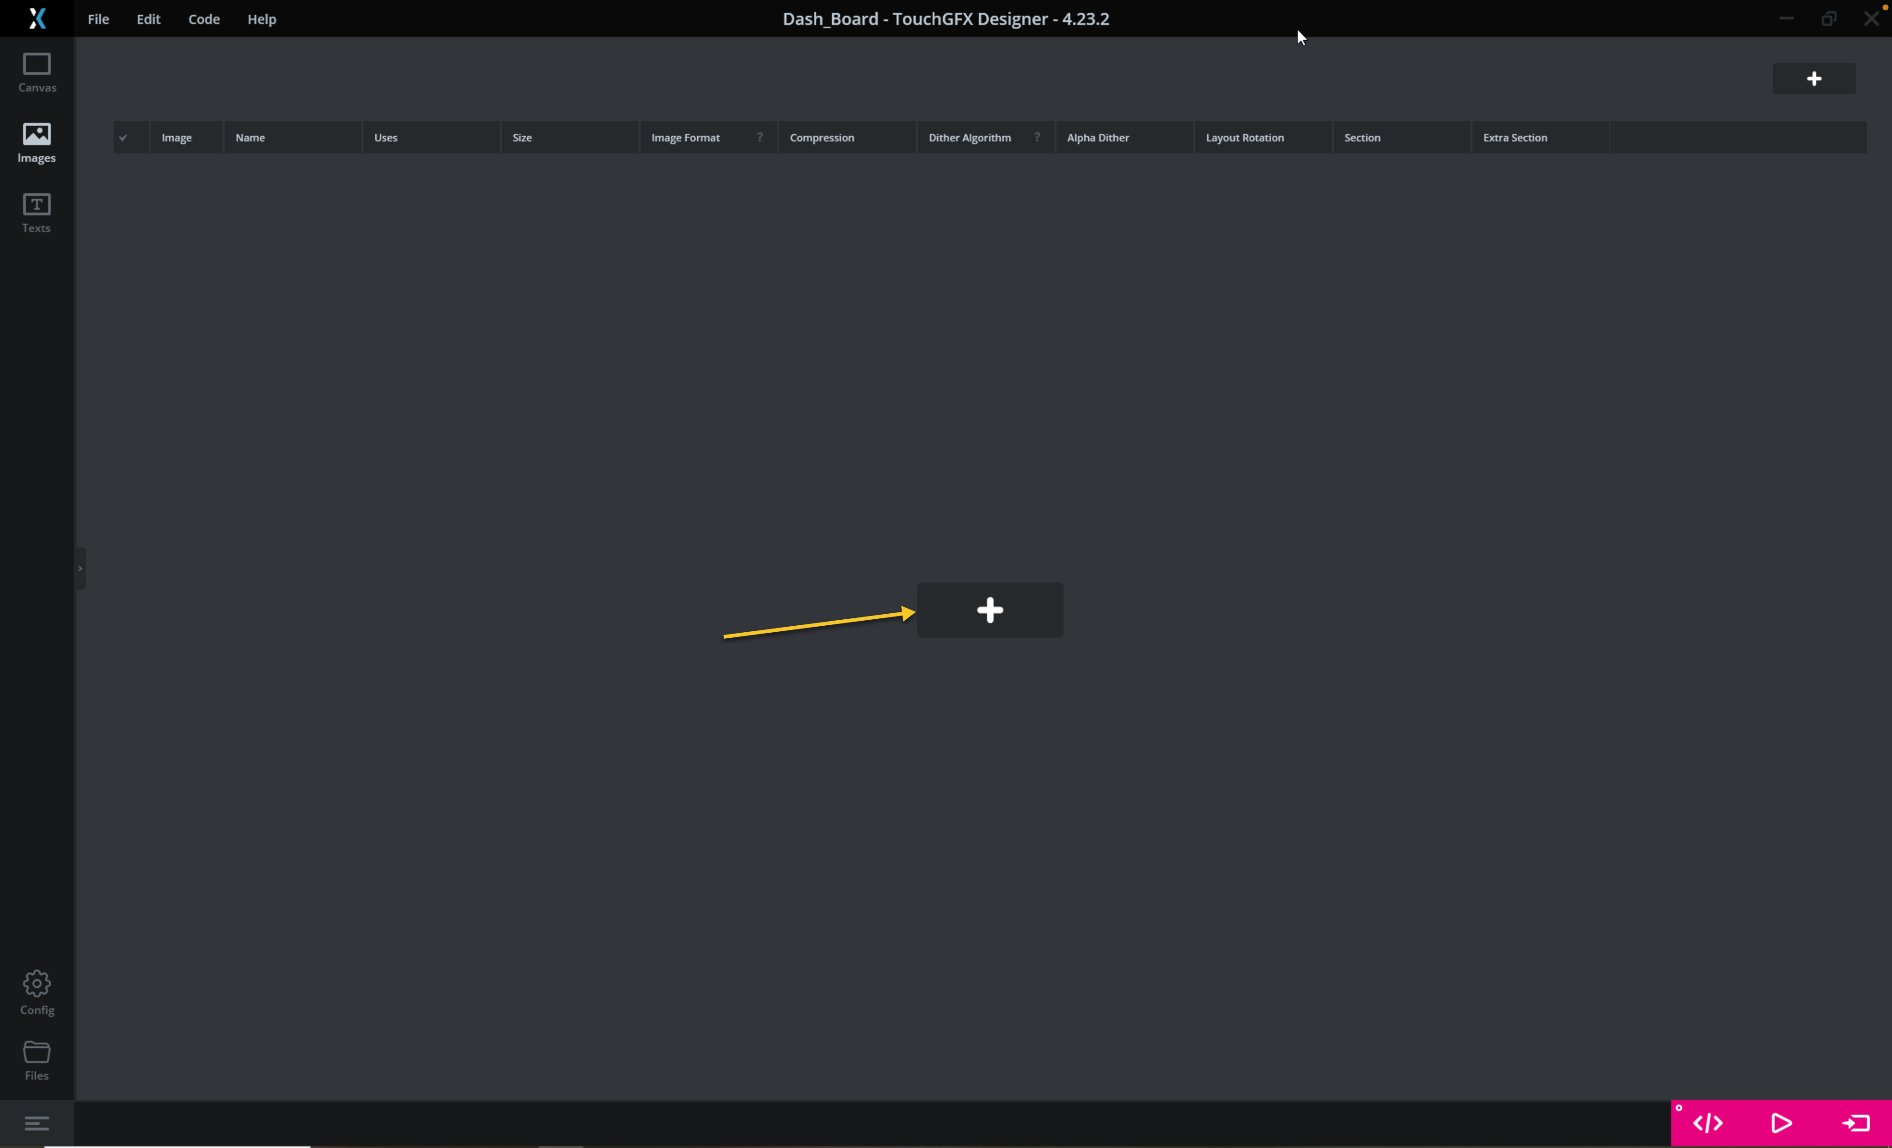
Add all the pictures downloaded from the repository.
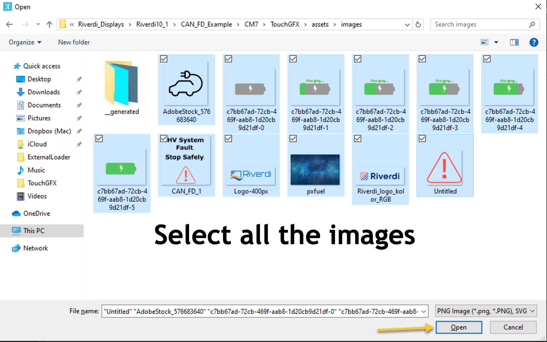
Next, from the left side, select Texts then Typographies as following:
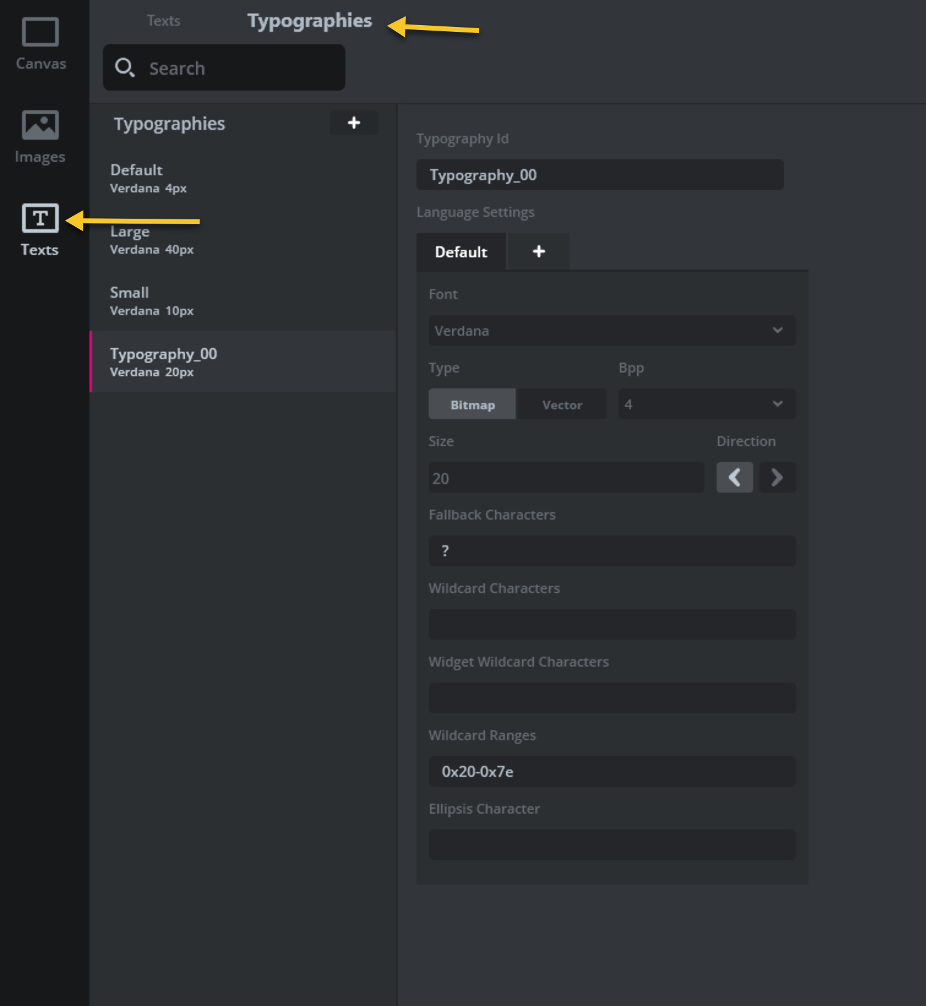
Create new typography by clicking on the + sign and set the parameters as following:
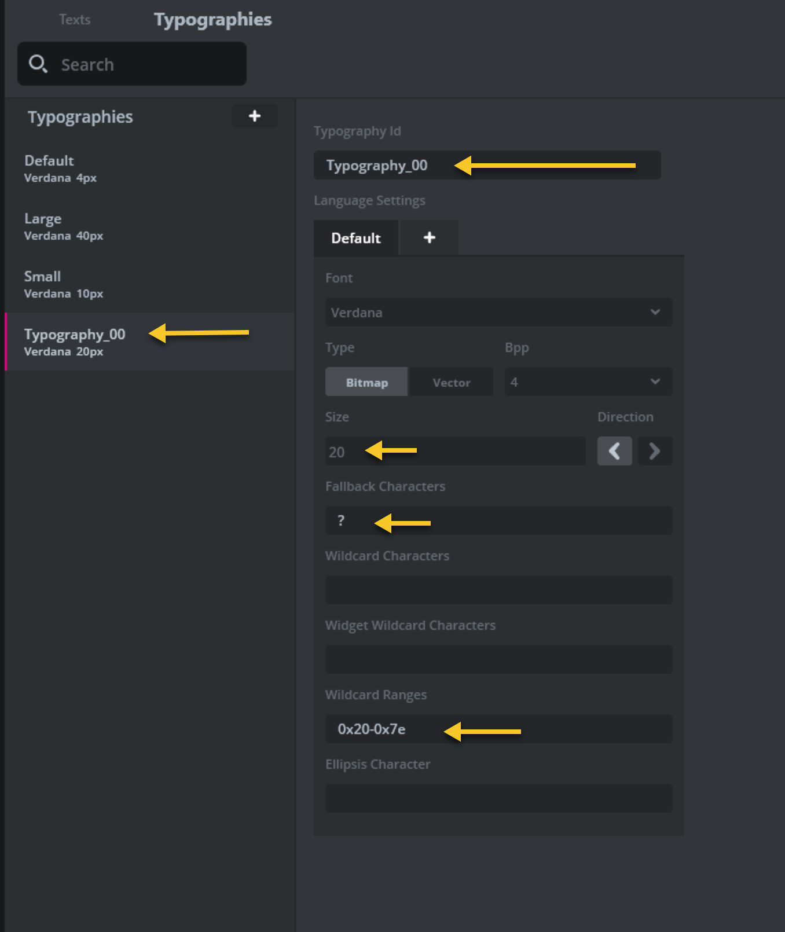
Give the typography a name, Set the size to 20, Fallback character to ? and the range to be from 0x20 to 0x7e which will cover all the printable characters.

From the left side menu, click on convas.
Next, adding the background.
From top middle menu select images, image as following:
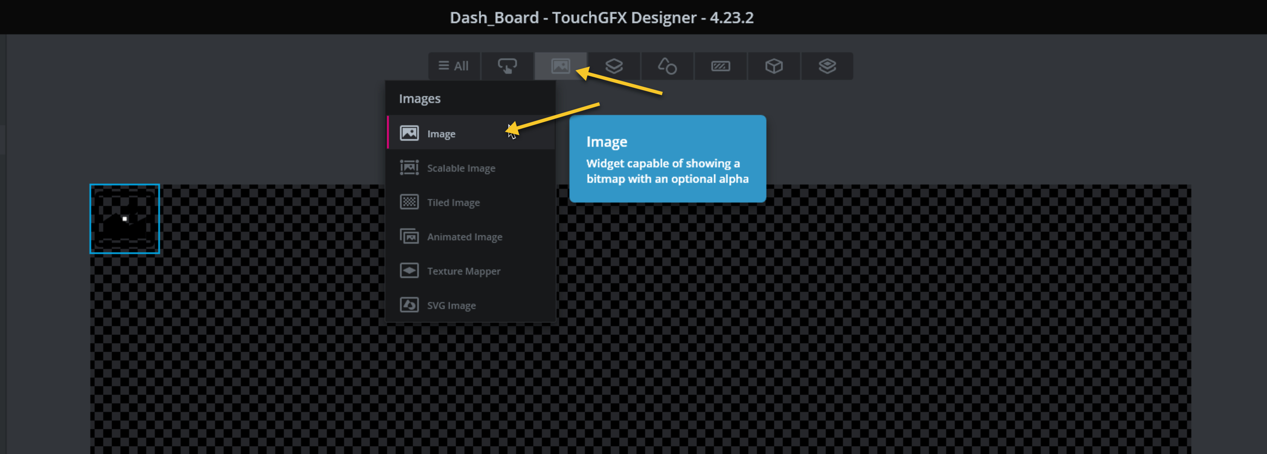

From the right menu, select the image as following:
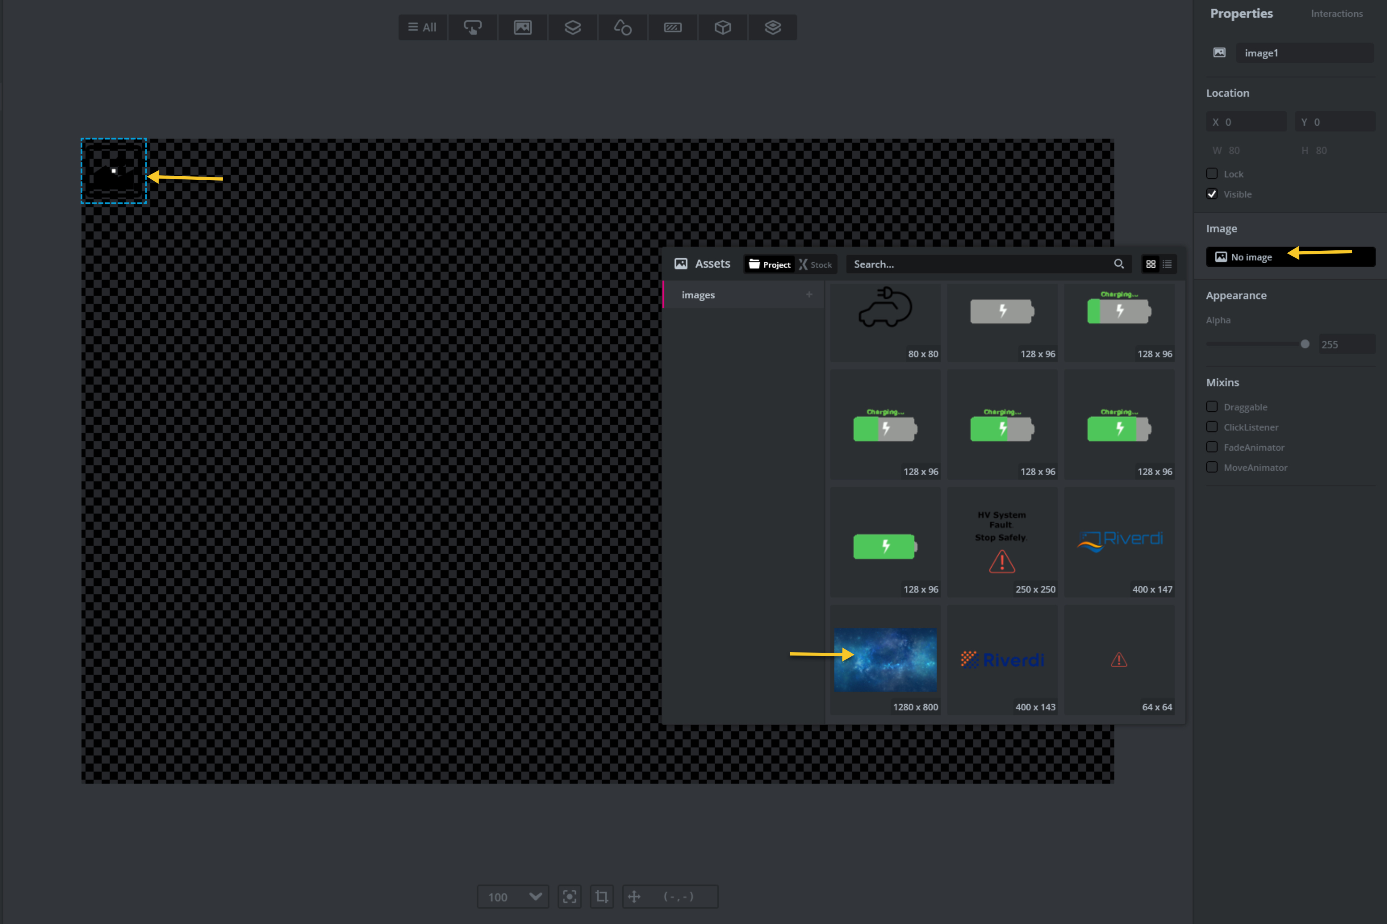
Also, add animated picture as following:

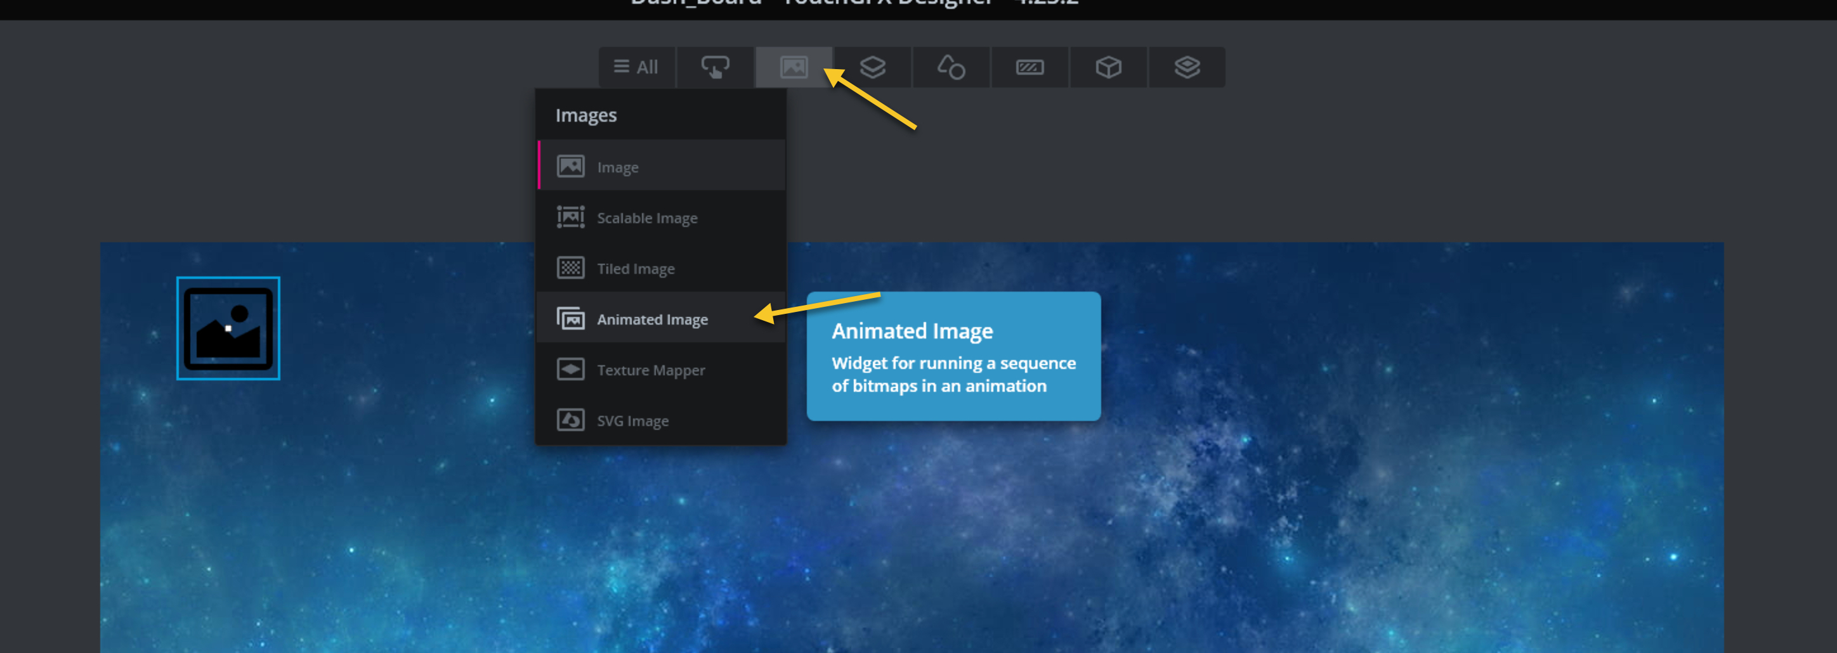
Add a progress image as following:
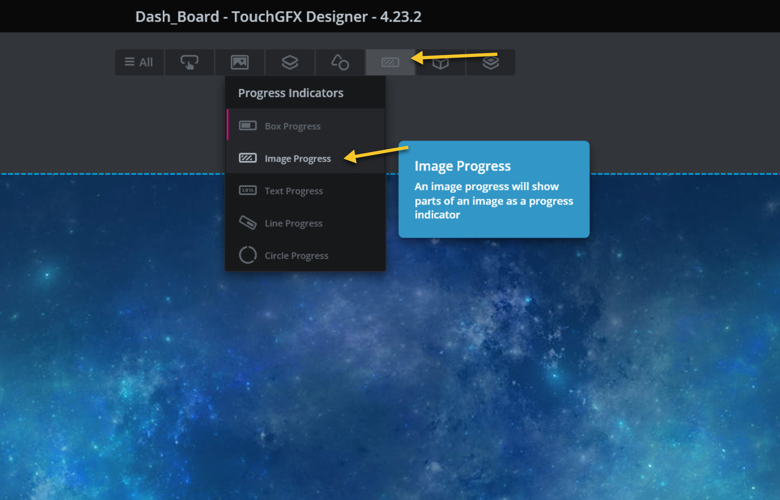
Add text area as following:

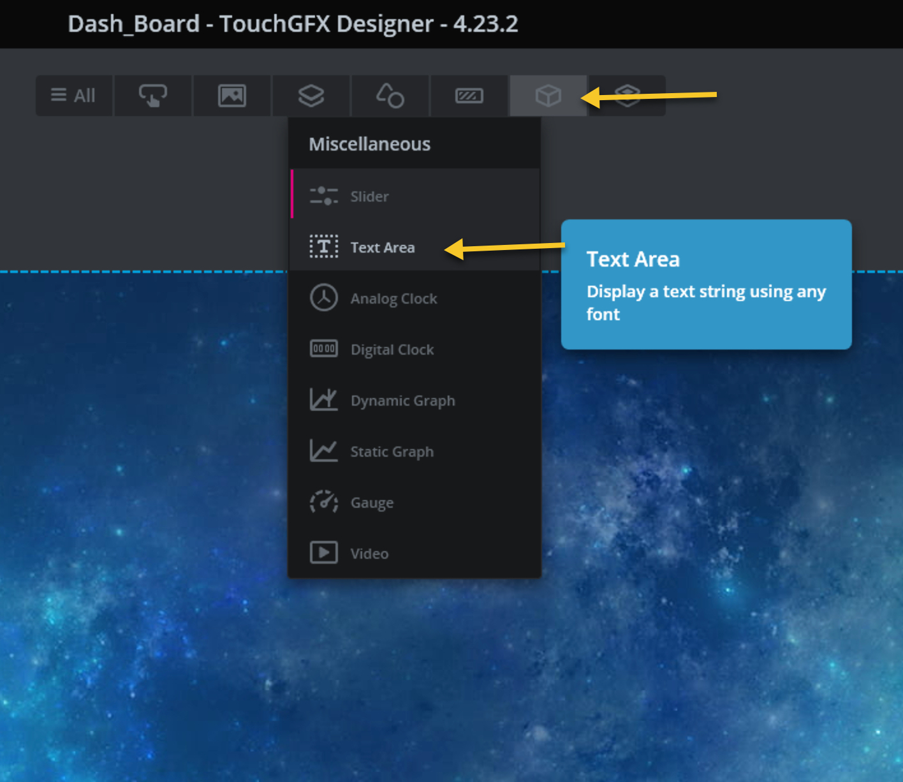
For the text area, make sure it has the following properties:
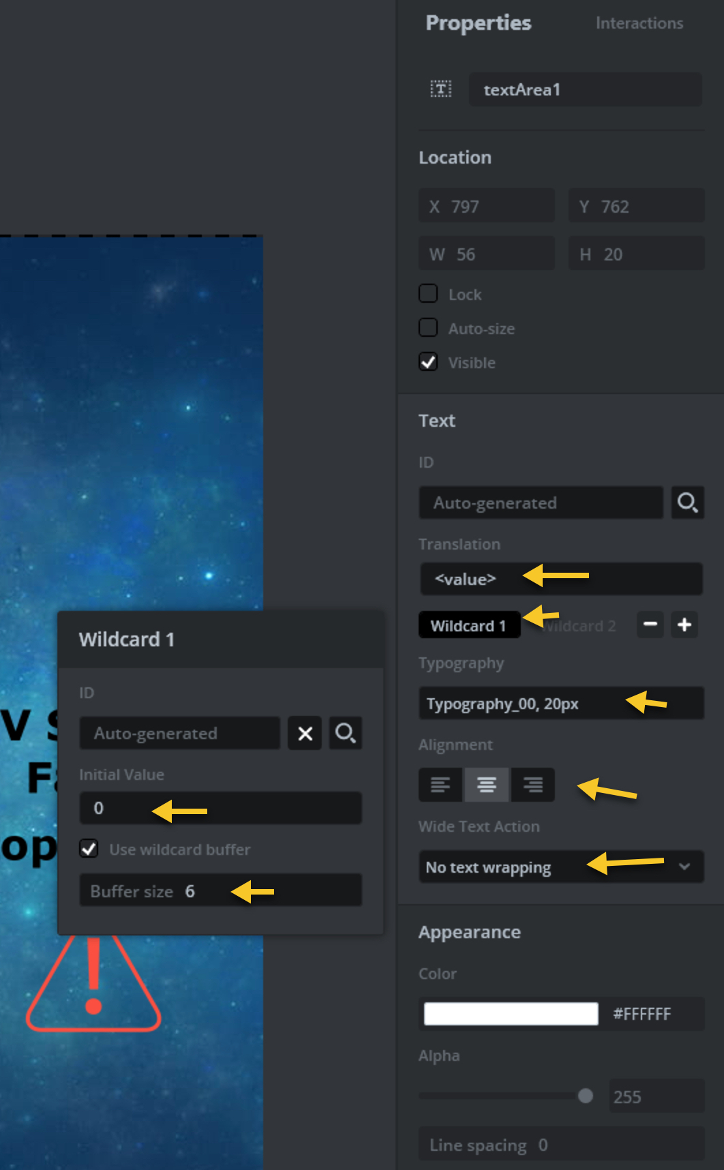

Create an UI as following:

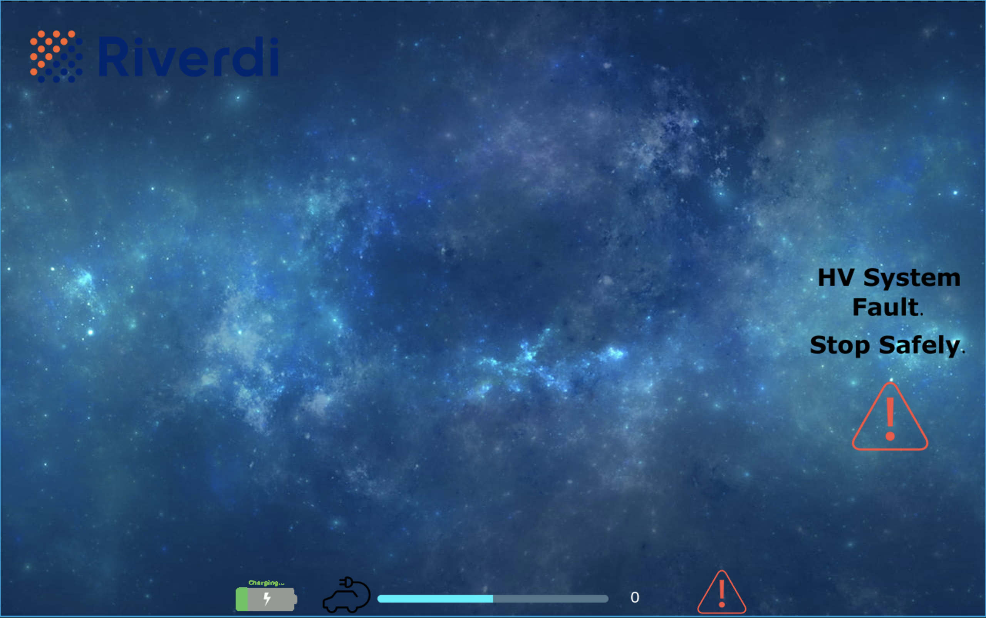
Next, Run the project on your board.
Next, connect your ST-Link programmer to SWD port of Riverdi Display using RVA-SWD-06M-C100 cable.
From the bottom left, click on the run on target button as following or simply, press F6:

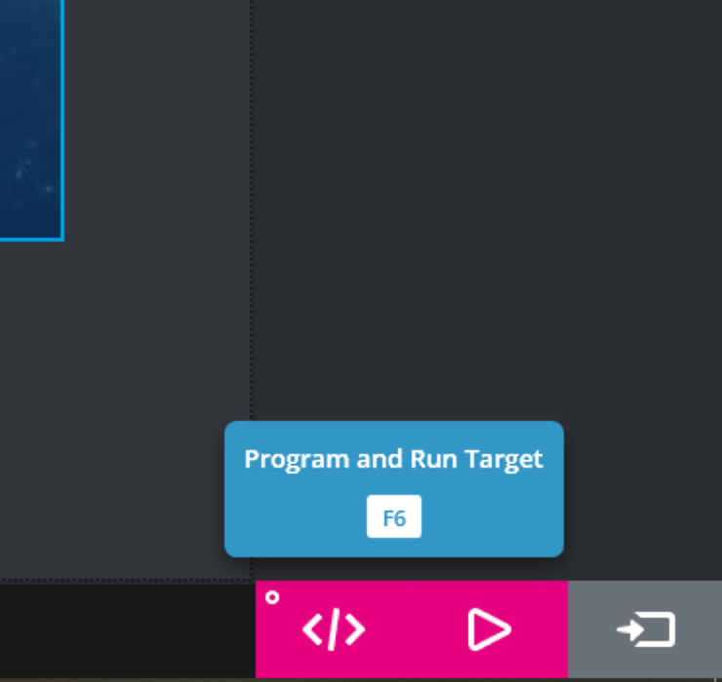

Once the compile and flash is completed, you should see this on your screen (10.1”).
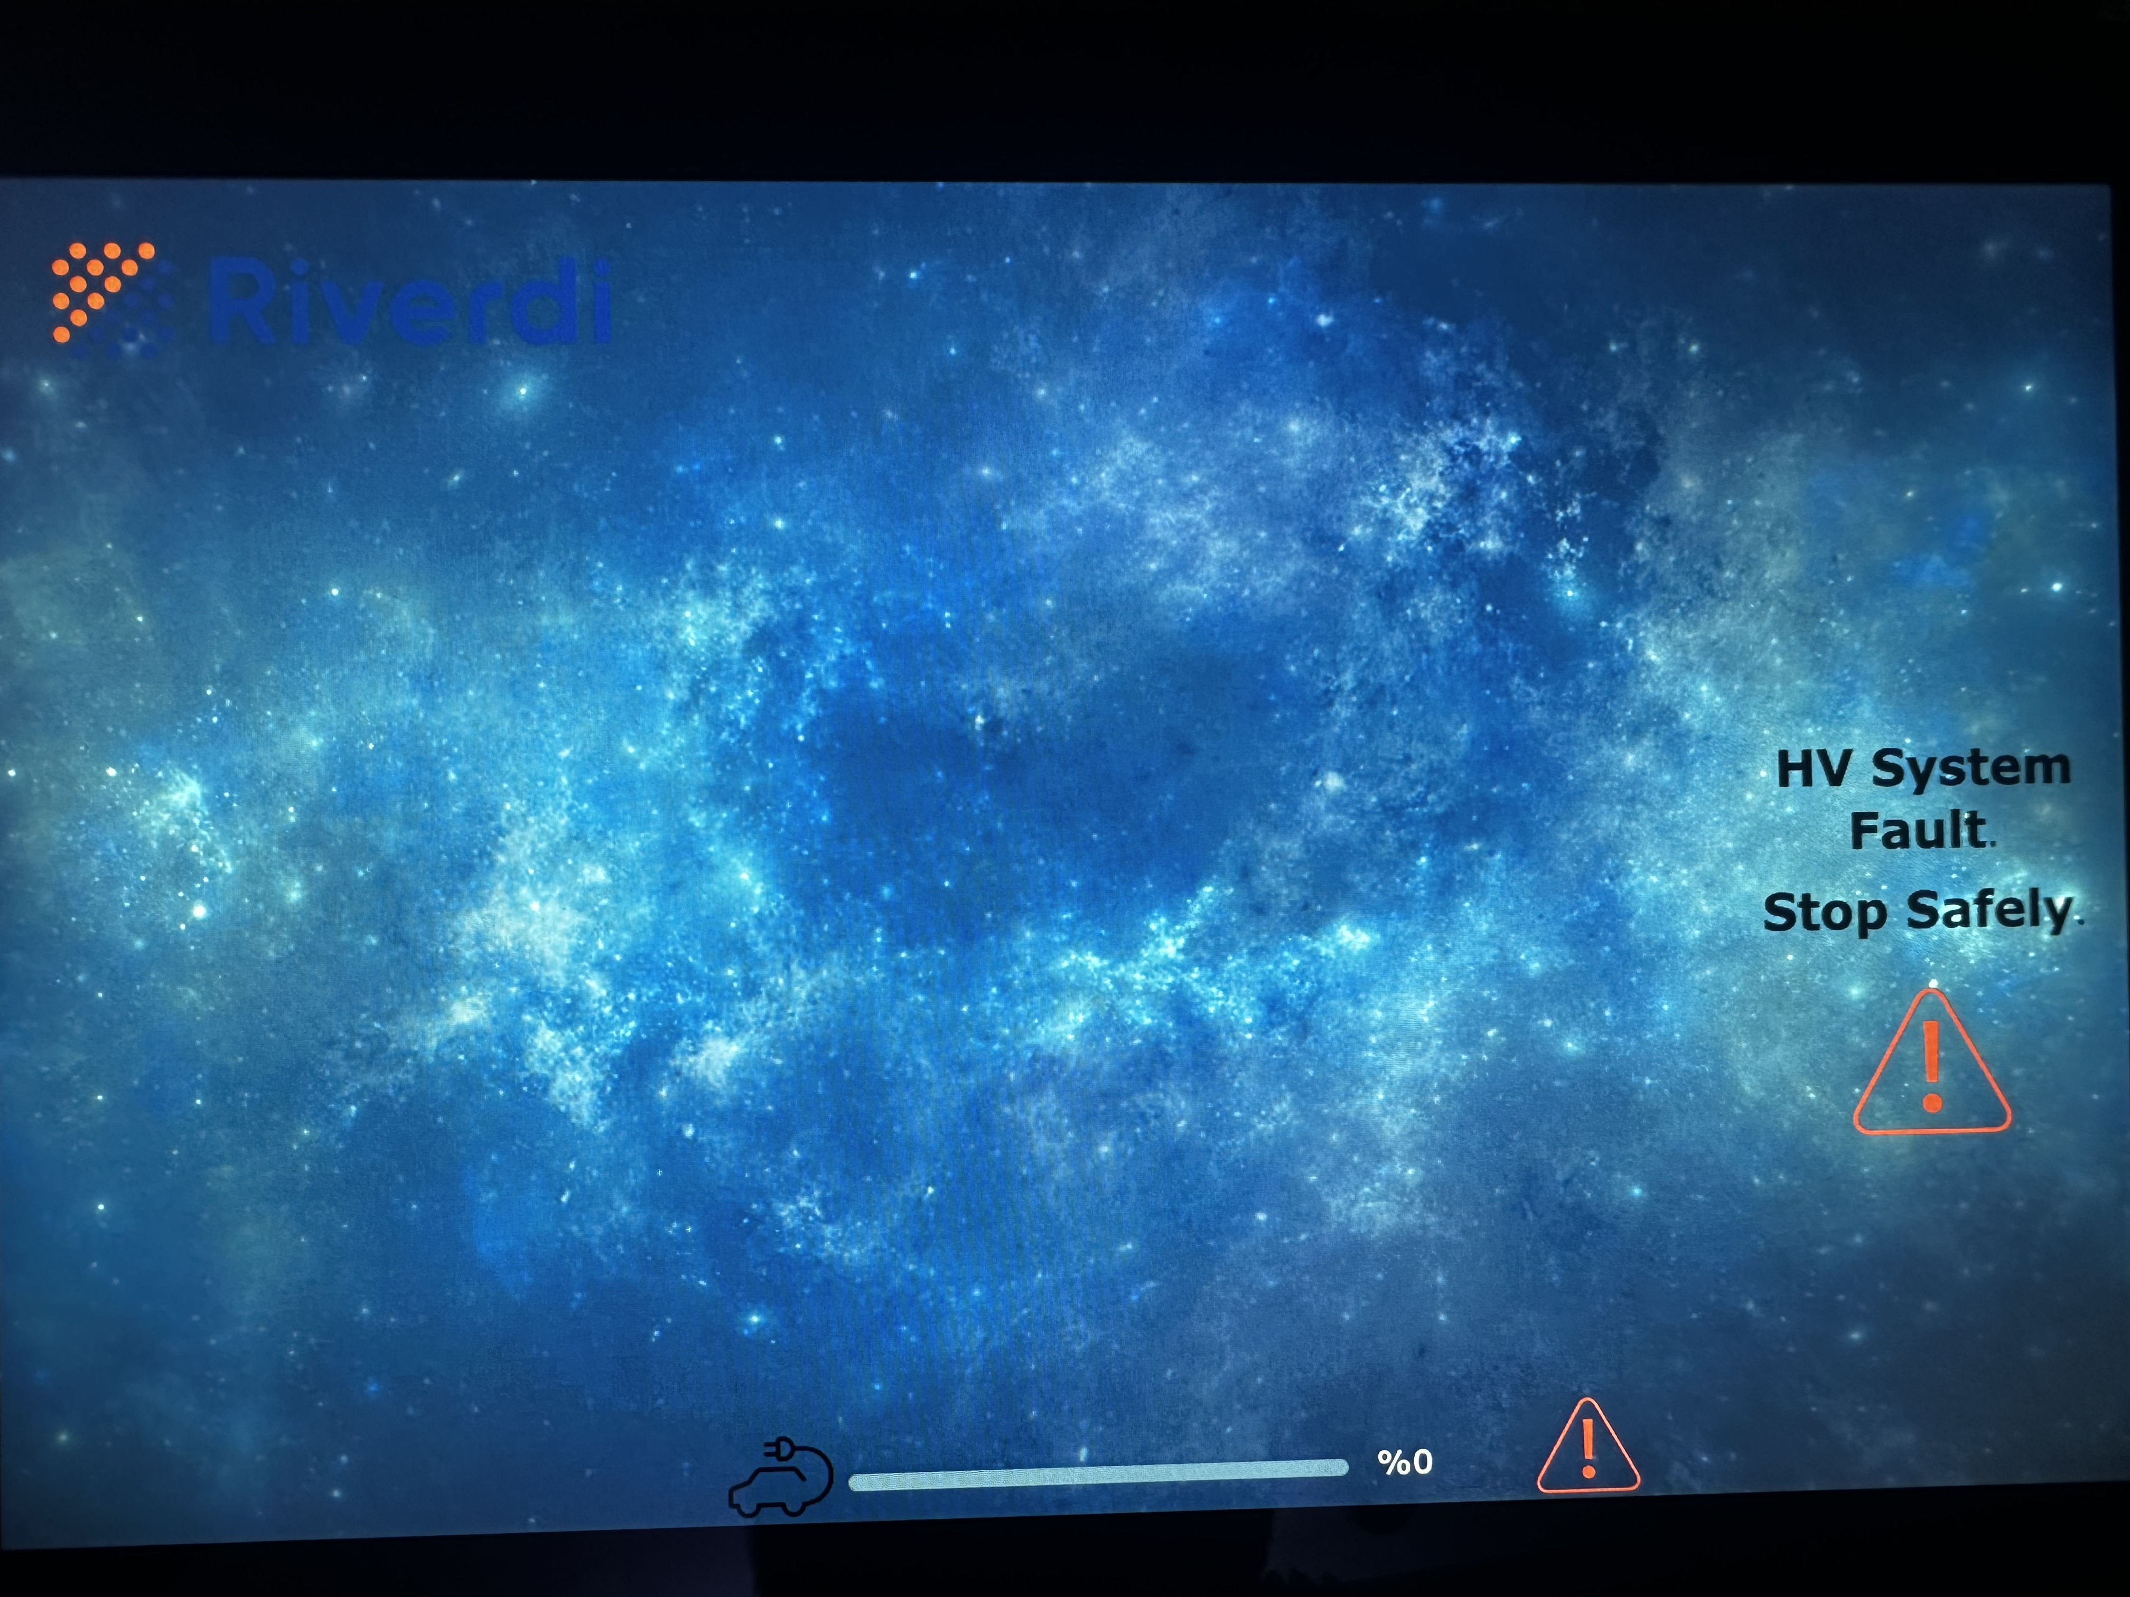

Next, select the charging indicator as following:

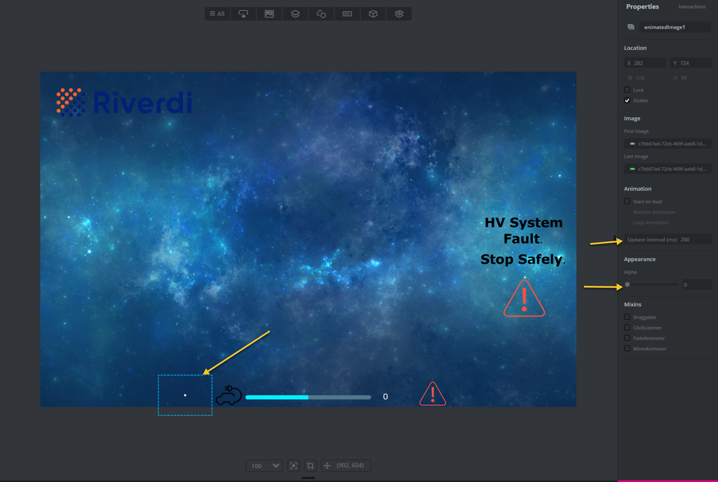
From the right menu after selecting the gif picture, set the update interval to 200ms and set alpha to 0. By setting alpha to 0, this will make image not visible at all. The behavior shall be done in the firmware. Also, enable the start on load, enable repeat animation then disable the start on load.
Repeat same steps for HV System Fault picture and caution picture except the update interval since they are static images.

Thats all for creating the UI for the 10.1”Riverdi display which should emulate the dashboard of the EV.

3. Developing UI for Riverdi 7.0” Display:

Starr by creating new project using TouchGFX:

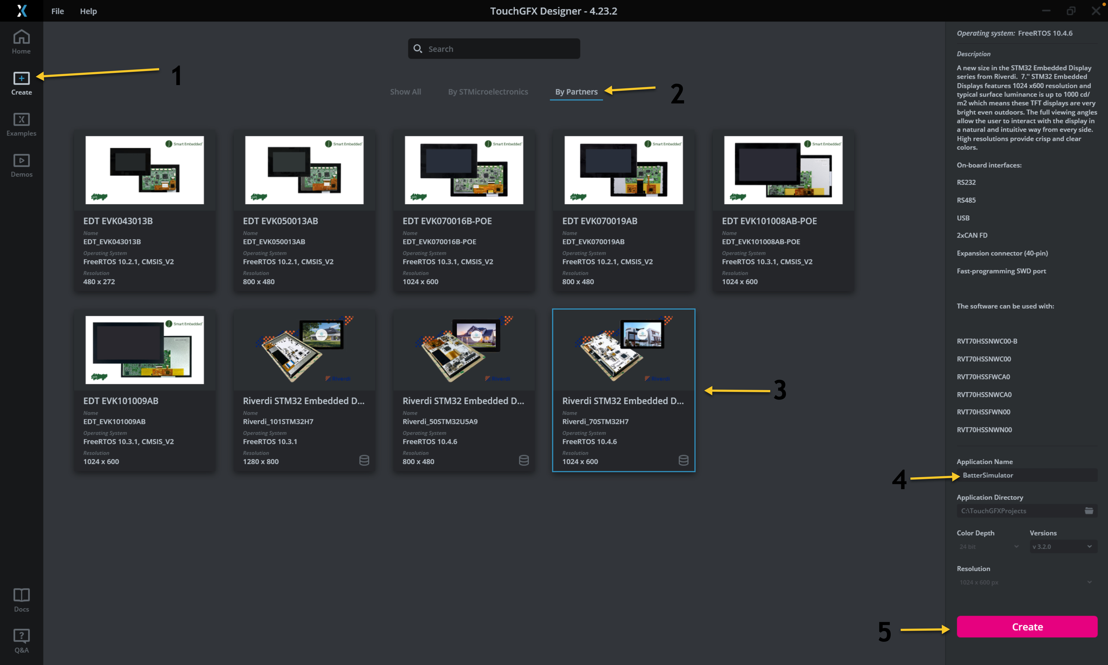

- From left side, select Create.
- Go to By Partners tab.
- Select Riverdi_70STM32H7.
- Give the project a name.
- Click on Create.

Next, get the required assets from this github repository.

With similar steps to the Riverdi 10.1” display, create the UI as following:
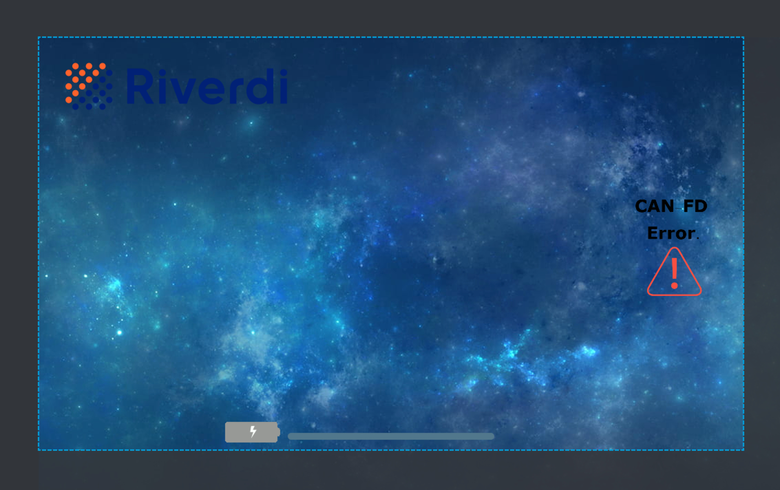
Repeat the same steps for the CAN-FD error image by setting alpha to 0 and same steps for the gif.

Thats all for the UI development.

4. CAN-FD Configuration:

This section is applied for both, Riverdi 10.1 and Riverdi 7.0 displays since they have identical STM32H757 MCU.
Go to the project folder and open STM32CubeIDE folder as following:
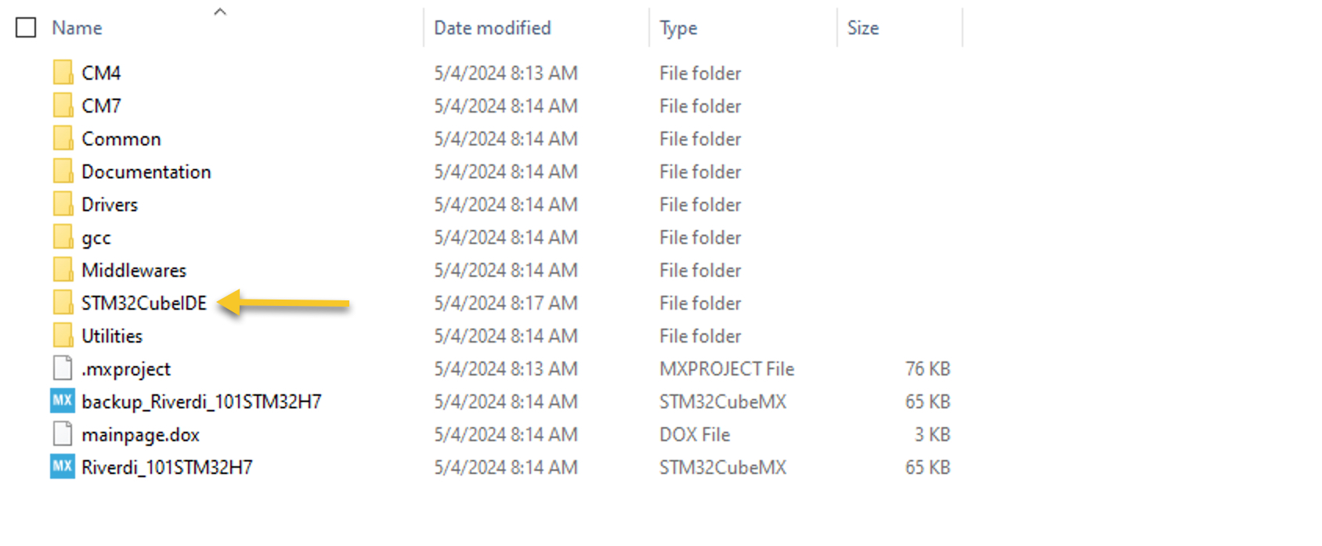

Then open .project file as following:
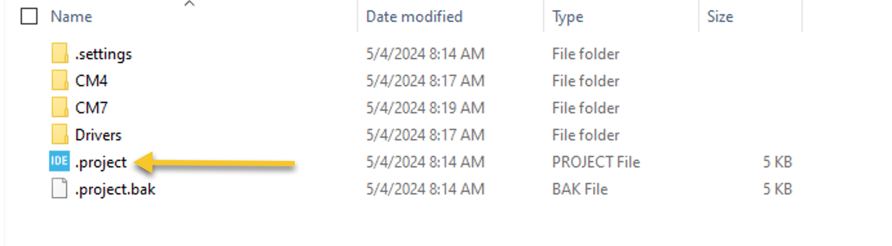
After that, STM32CubeIDE will ask you for workspace location, set the appropriate location according to your setup (In this case, Riverdi is used).
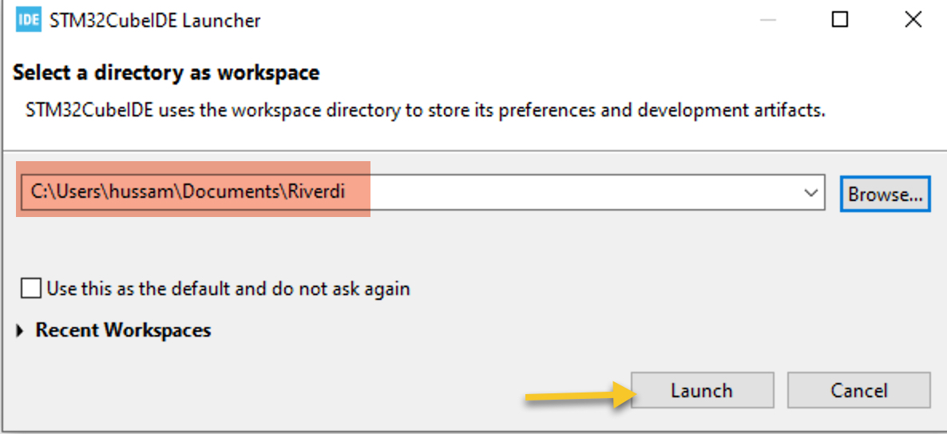

After that, the IDE shall started and import the project. Give it about minute to finish the importing process.
From the left, in project explorer, open Revirdi_101STM32H7.ioc file.
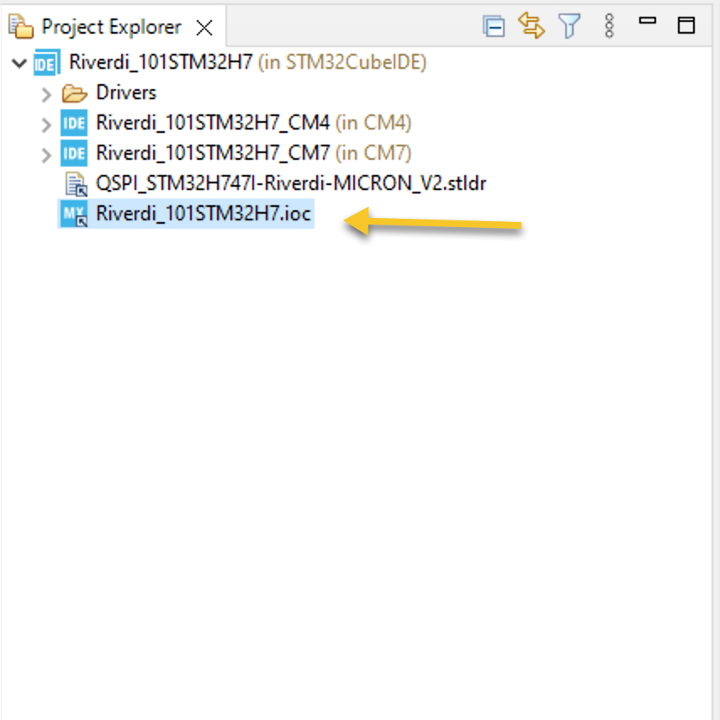

Then click on Yes to change the respective view:
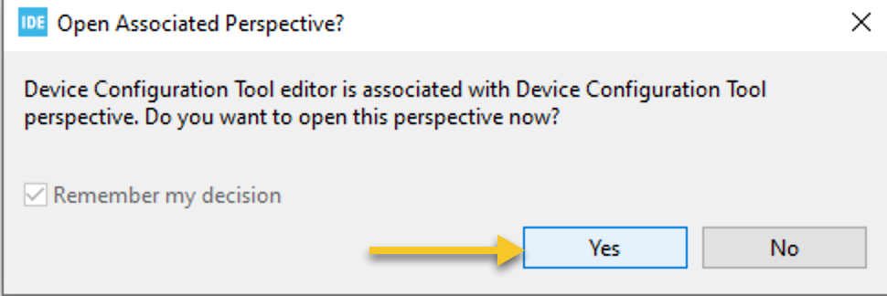

Then click on Continue:
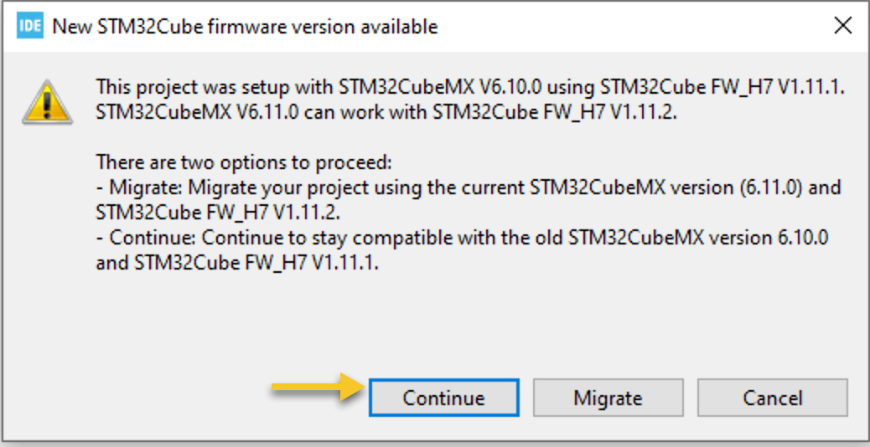
This is due to older version of STM32CubeMX is used when TouchGFX generated the code compare to the most recent version install in the STM32CubeIDE.
From the left side of STM32CubeMX, select connectivity, then CAN-FD 1 and configure it as shown below:

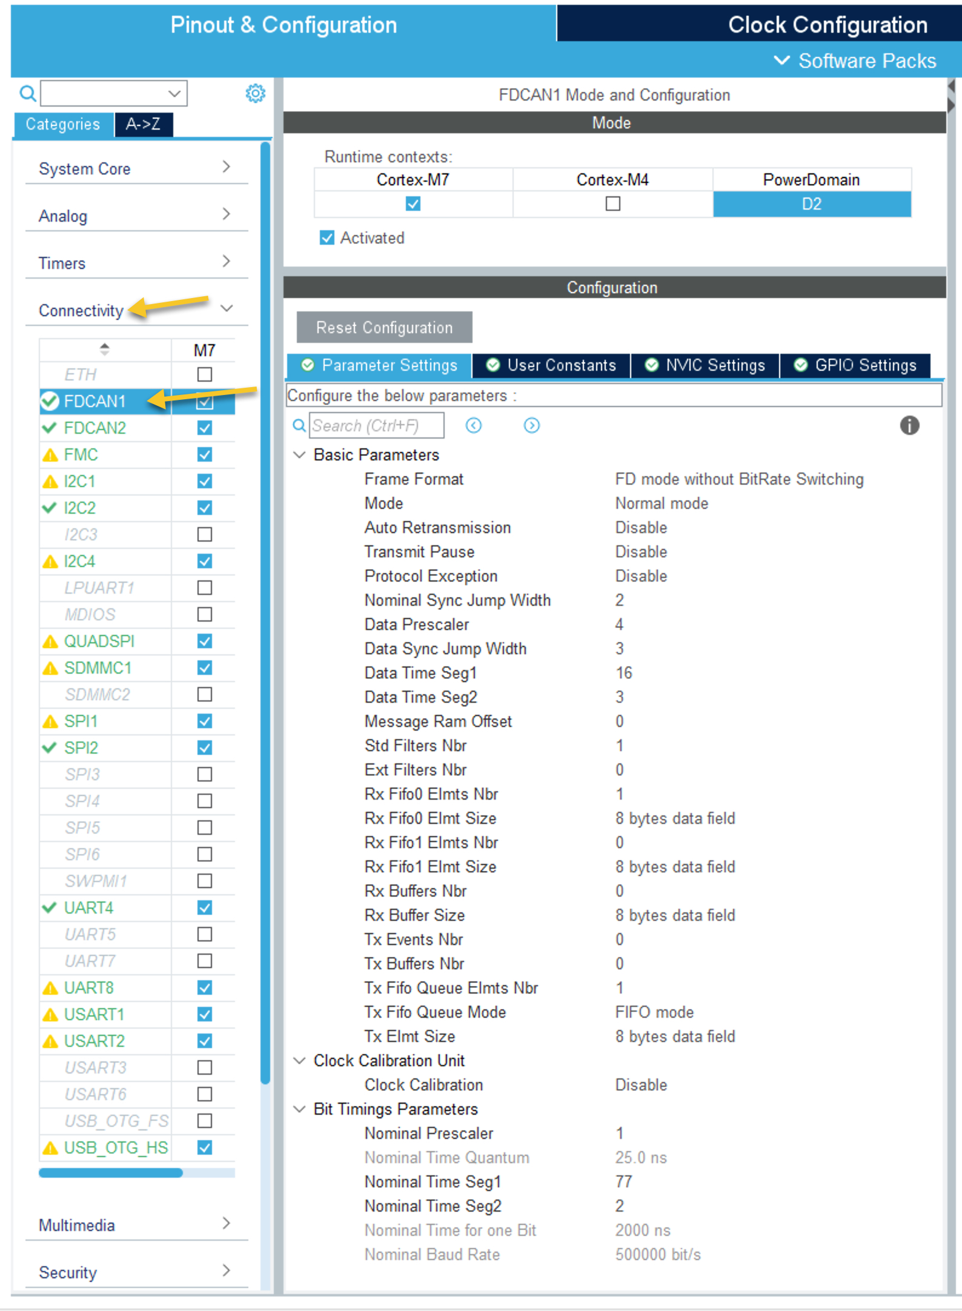
With these settings, the CAN-FD will operate at 500Kbps.
You can adjust these value according to your need. For CAN-FD timing calculation, please refer to this website.
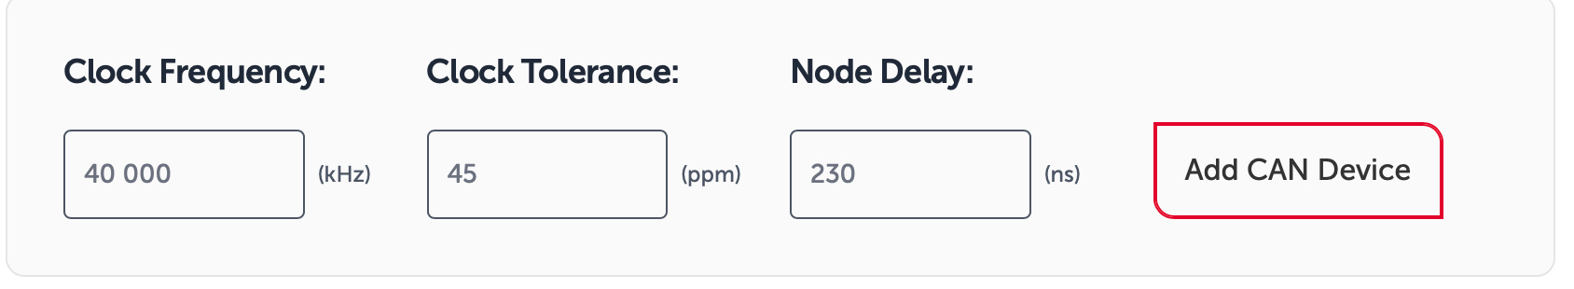
Then, select the bit rate for nominal and data (500K in this case) and adjust the values to match the range within STM32CubeMX.

Next, from NVIC settings of CAN-FD1, enable interrupt for CAN-FD1 interrupt 0 as following:
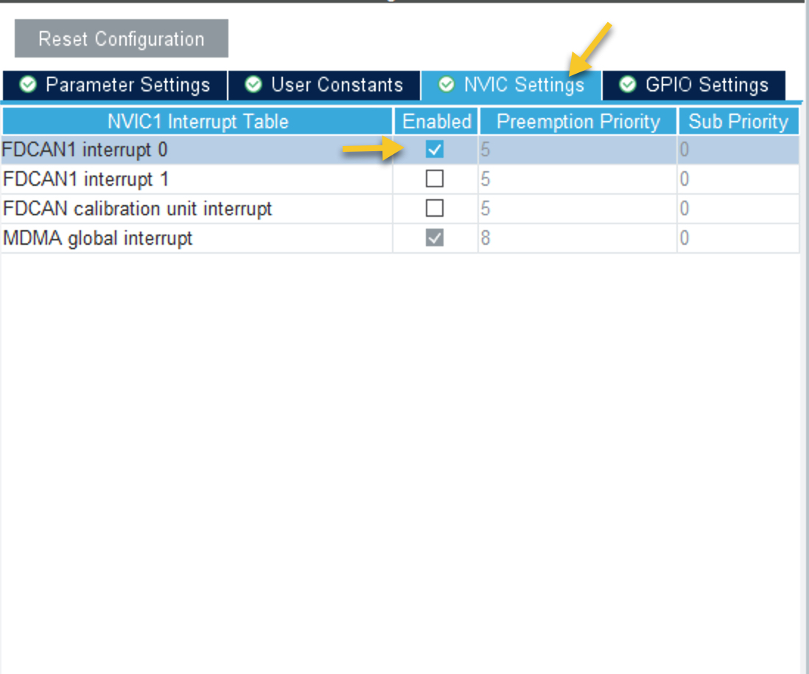
Now, from top menu, please click on generate code as following:
This will save the project and generate the code.

Repeat the same steps for Riverdi 7.0 display and use the same parameter used in Riverdi 10.1.

5 FreeRTOS Configuration for Riverdi 10.1:

In order to configure freeRTOS, first open the Riverdi_101STM32H7.ioc file as following:

From the left side of STM32CubeMX window, select Middleware and software pack, then FreeRTOS_M7 as following:
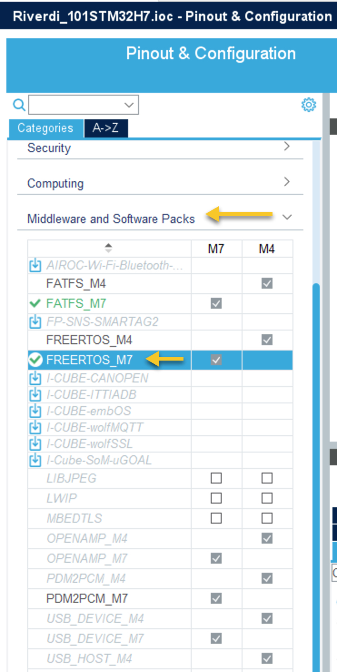

Next, from tasks and queues, click on Add for task as following:
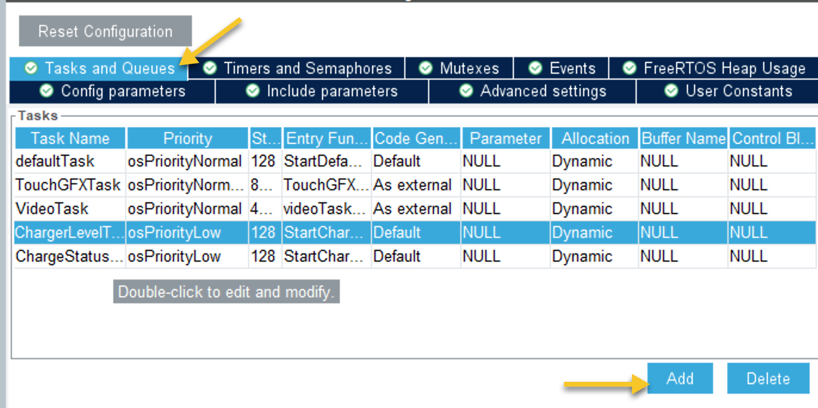
Create a charge task with the following parameters:

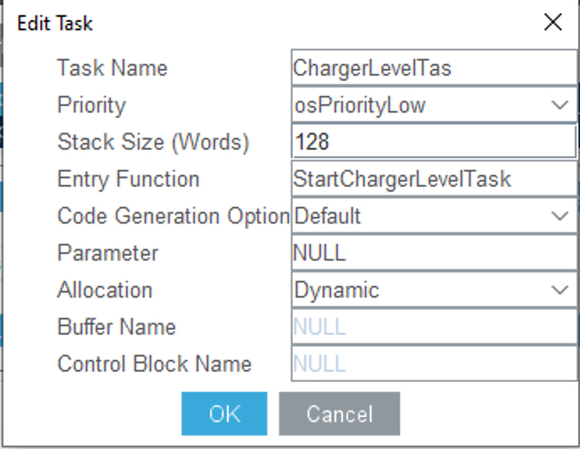
Create Charge status task with the following parameters:

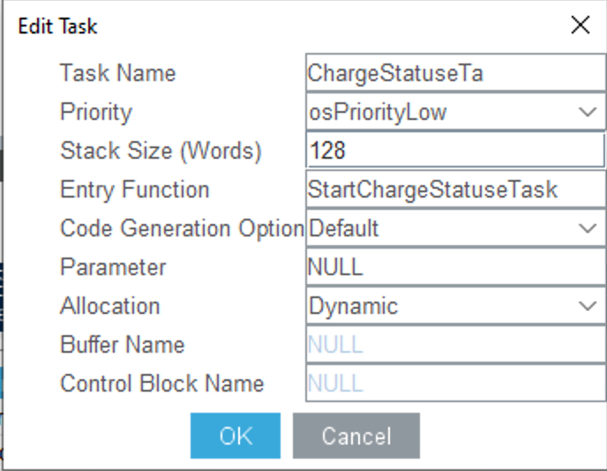
Next, from Queues, create three queues with the following parameters:
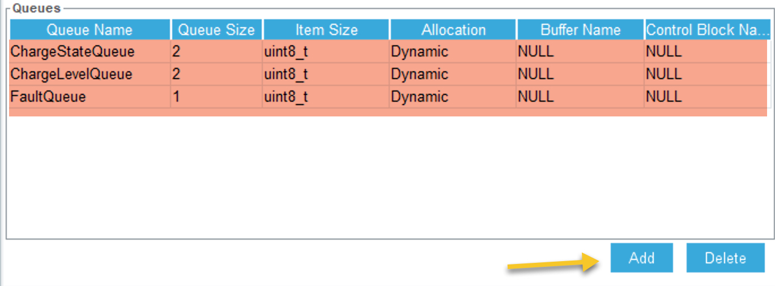
Make sure that all of them are uint8_t for item size.

Now, from top menu, please click on generate code as following:
This will save the project and generate the code.

6. FreeRTOS Configuration for Riverdi 7.0:

In order to configure freeRTOS, first open the Riverdi_70STM32H7.ioc file as following:

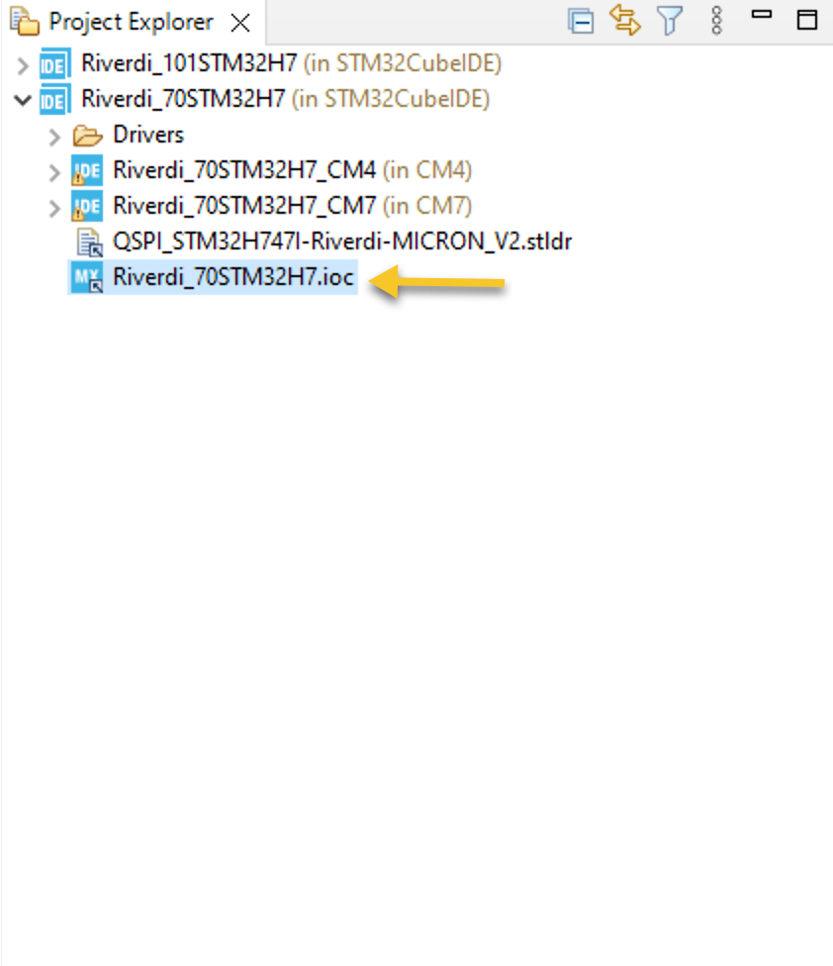
From the left side of STM32CubeMX window, select Middleware and software pack, then FreeRTOS_M7 as following:

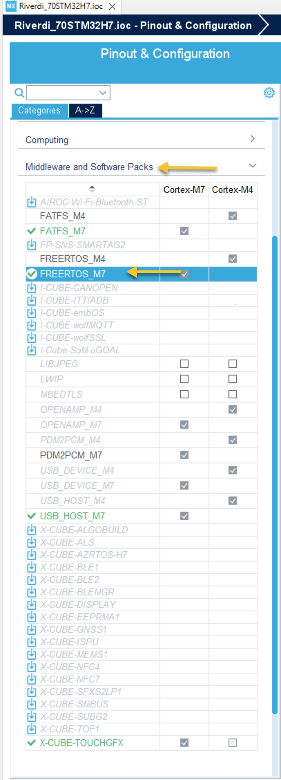

Next, from tasks and queues, click on Add for task as following:
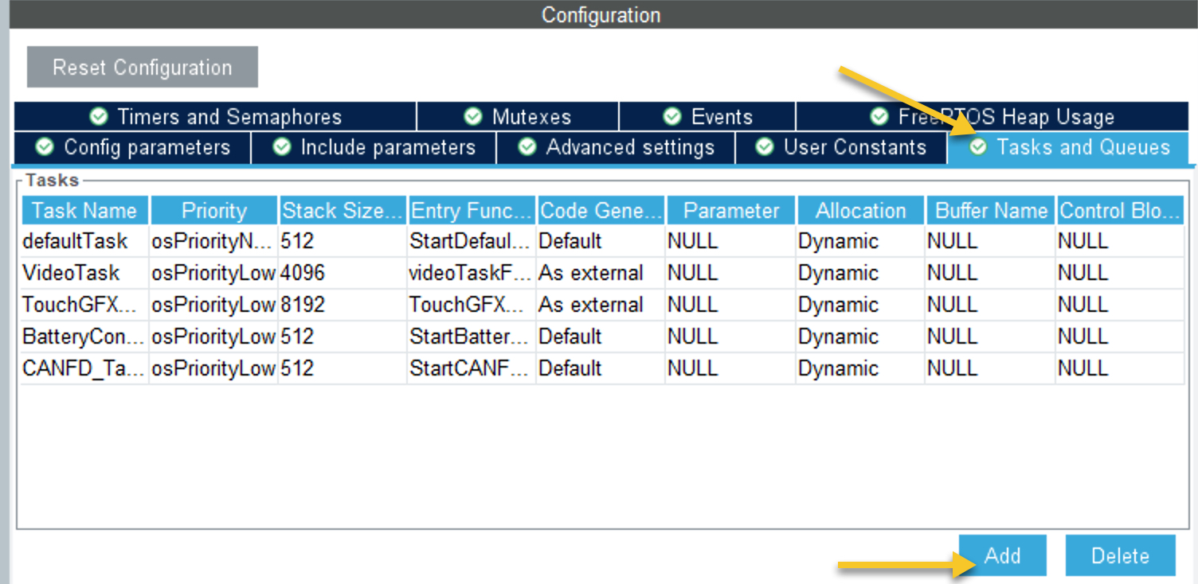
Add new task for battery controller with the following parameters:
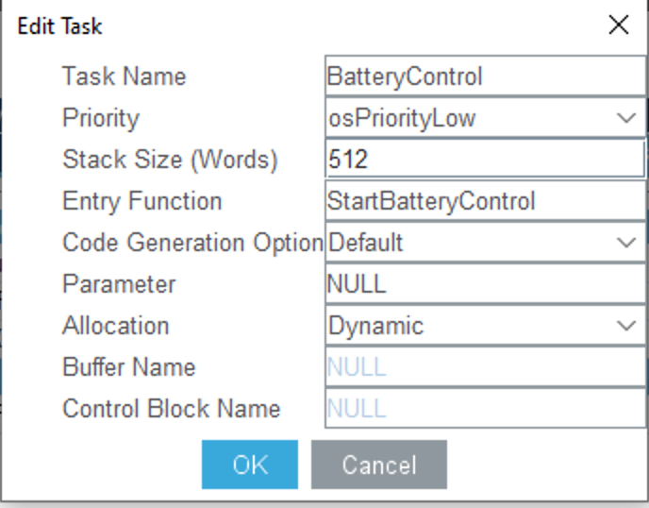

Also, add CANFD_Task with the following parameters:

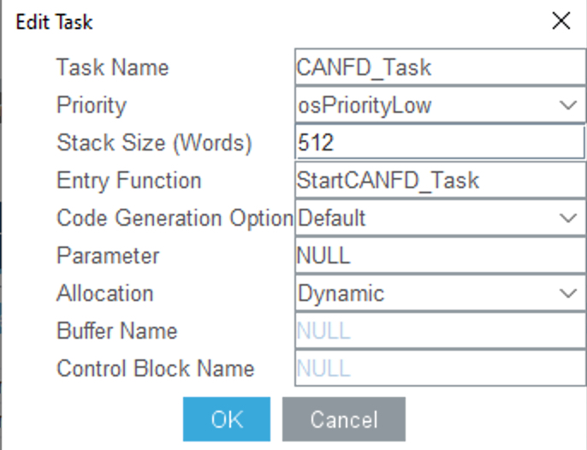
Also, create new queues with the following parameters:
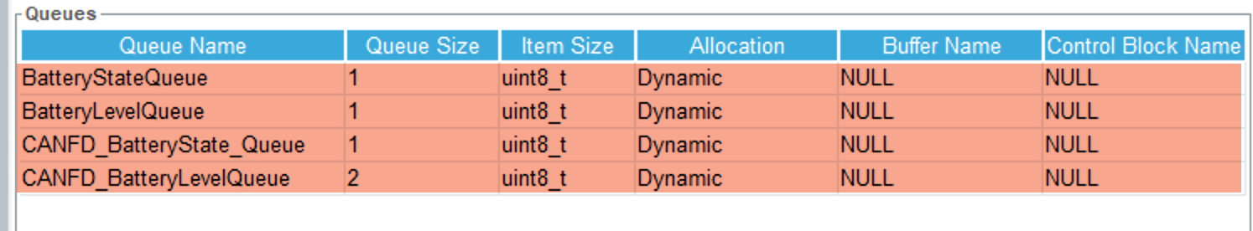
Make sure that all of them are uint8_t for item size.

Now, from top menu, please click on generate code as following:
This will save the project and generate the code.

7. Firmware Development for Riverdi 10.1:

Start by opening the fdcan.c source file as following:
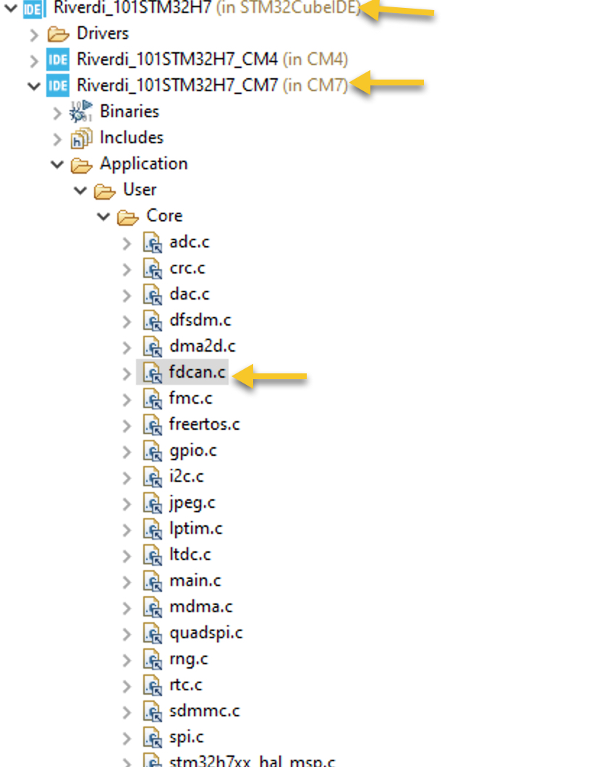

Since STM32CubeMX only initialize the CAN-FD peripheral, the use must configure the filters for the CAN-FD.

In the source file, within the user code begin 0, declare the following:

Note: When moving from this document to the blog, the codes shall be properly formatted and easier to be read. Similar to this guide and this guide.

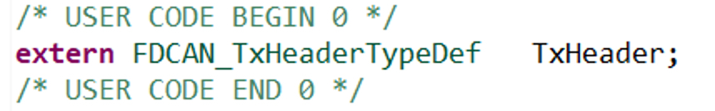
The TxHeader contents the data to be transmitted which is declared in another source file.
USER CODE BEGIN FDCAN1_Init 2, the CAN-FD filter shall be configured.
The configuration as following:

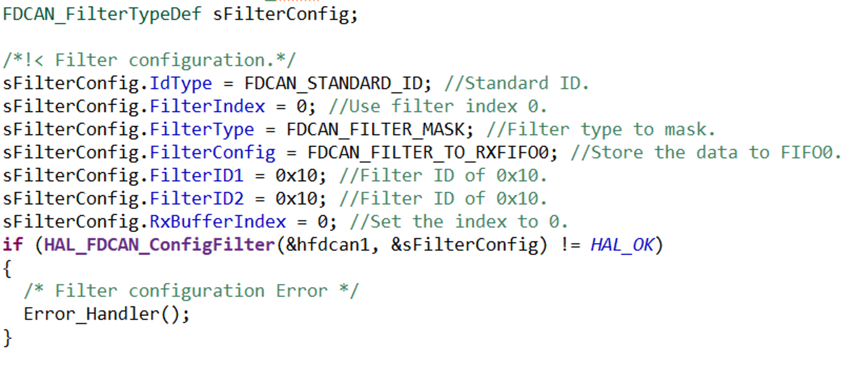
Next, Start the CAN-FD and enable notification as following:
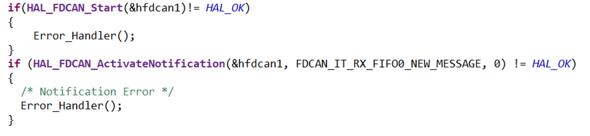

After that, configure the TX header as following in case the user wants to send data to the battery simulator as following:

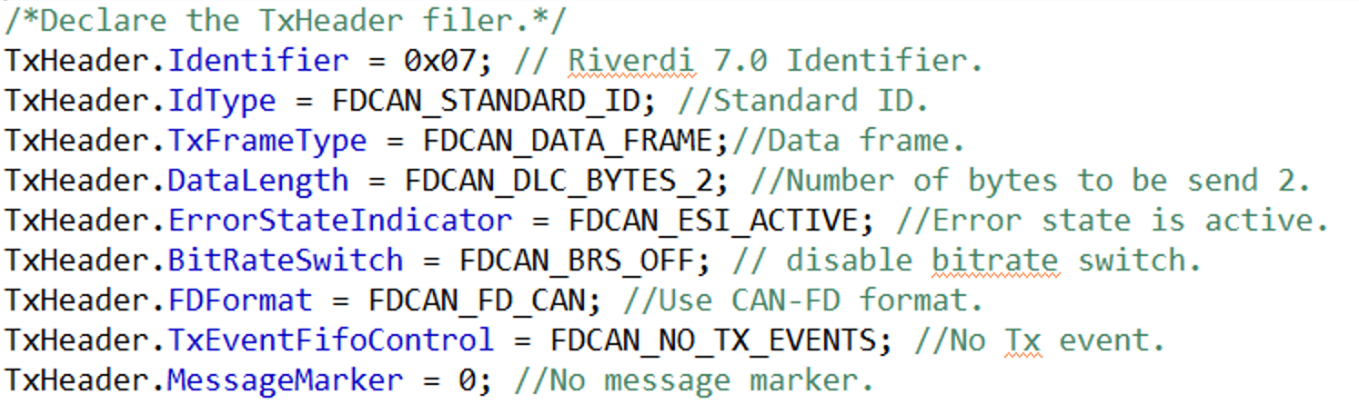
Next, open freertos.c source file.

At USER CODE BEGIN Variables, declare the following variables:
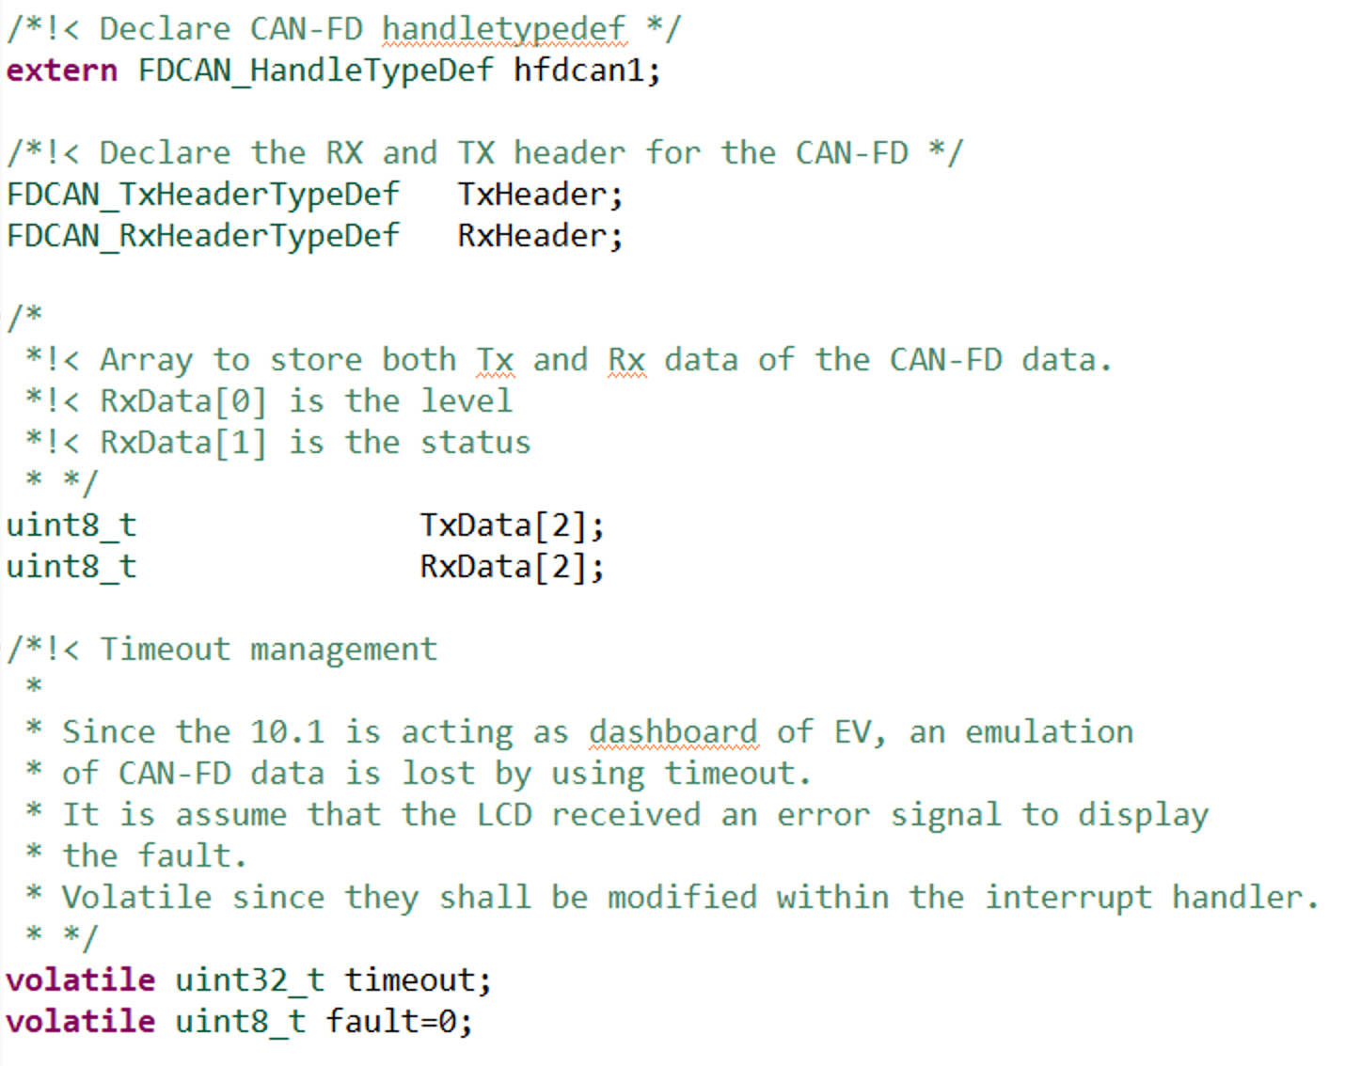

Since STM32CubeMX already generated the required RTOS functions, there is no need to write the functions of charge level and status.

Before handling the freeRTOS tasks, the interrupt of CAN-FD shall be handled first.

Within USER CODE BEGIN Application, declare the interrupt handler of CAN-FD FIFO0 as following:

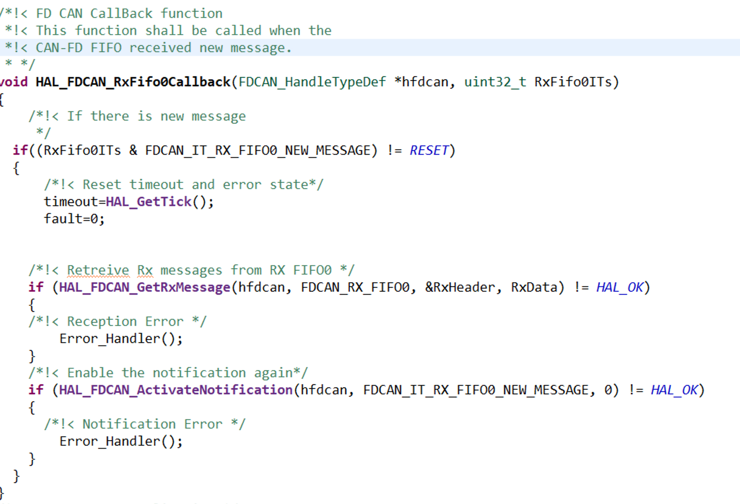
This callback function is called once the CAN-FD has received new message (From Riverdi 7).

For the timeout management, it is for simulating a fault in the battery system of the EV.

Next, the charge level task,
Within the infinite loop of the StartChargerLevelTask, the charge level shall be handled.
Since the battery simulator (Riverdi 7) sends two byte of data as following:
- First byte is charging status (charging discharging).
- Second byte is charging level (battery level).
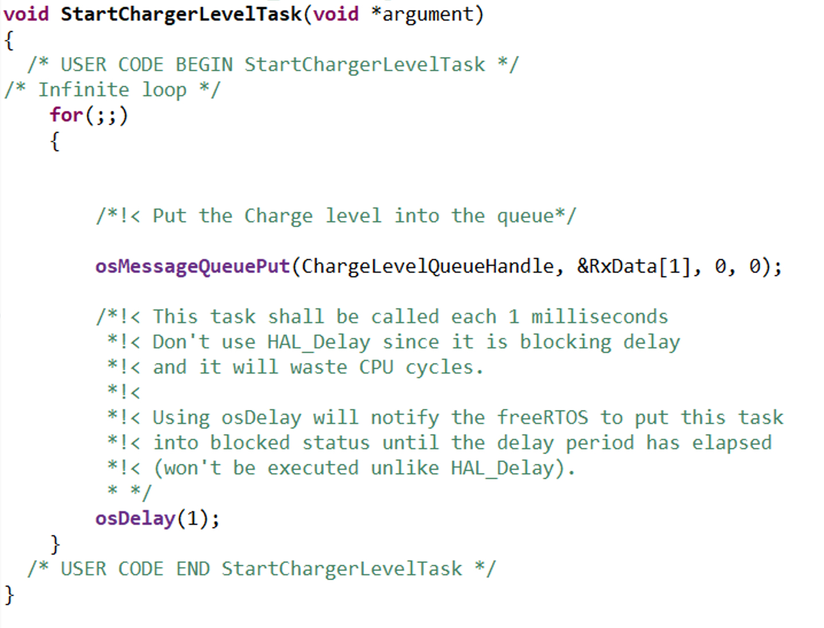
By putting the data in the queue, it allow the RTOS to use intertask communication to handle the data efficiently and synchronize the tasks.

In Similar manner for the charge status task:
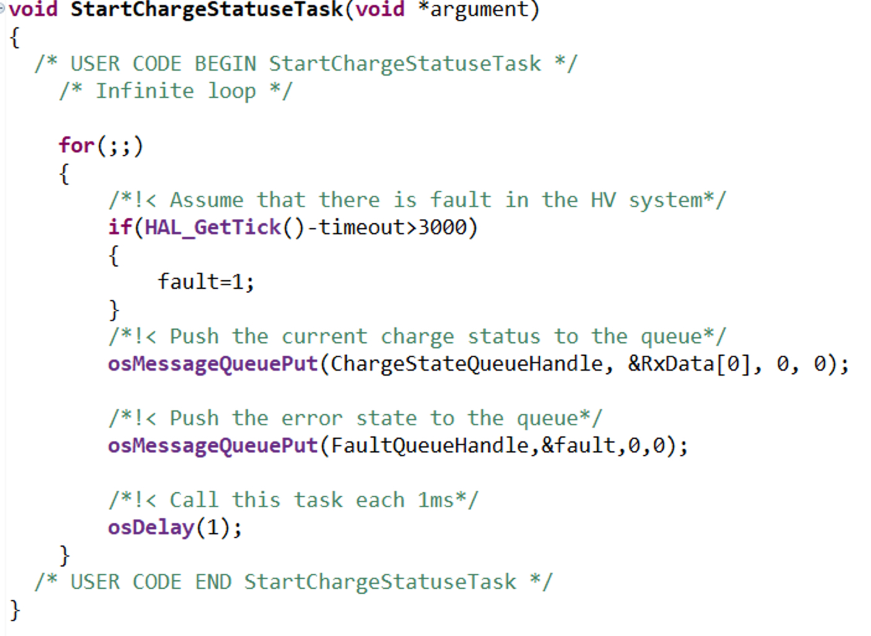
First, timeout handle to handle to error state of the HEV. In case no new data is received for 3 seconds, an error message shall be displayed. Also, send the charge status to ChargeStatusQueue and fault to the FaultQueue.

Next step, handling the data to be displayed on the screen.

From project explorer, open Model.cpp source file:

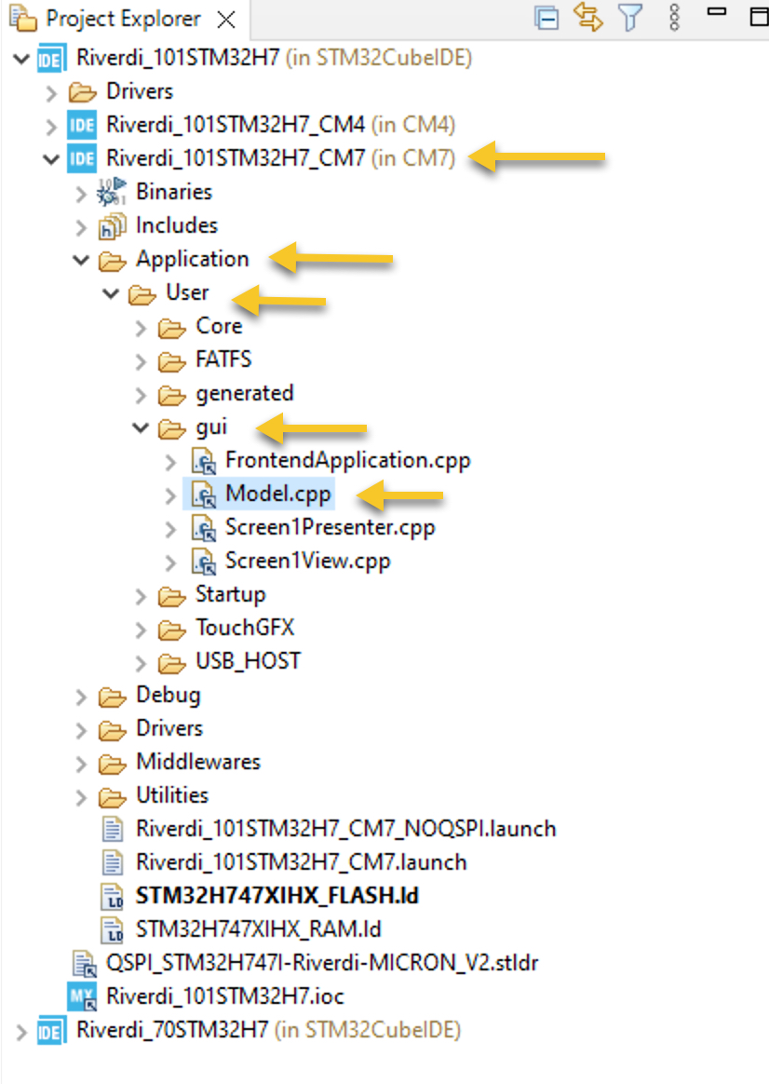

From the include section, open ModelListener..hpp as following:

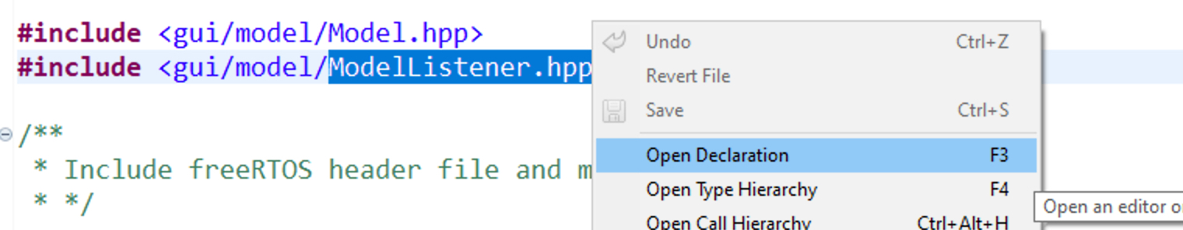

Within the hpp header file, declare the following functions as virtual.
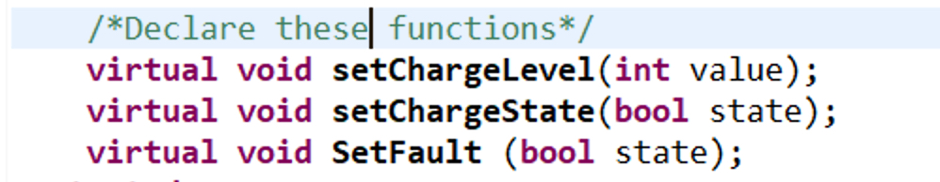

Save the changes.

In similar manner, open Model.hpp header file and declare the following variable in the protected section of the header as following:
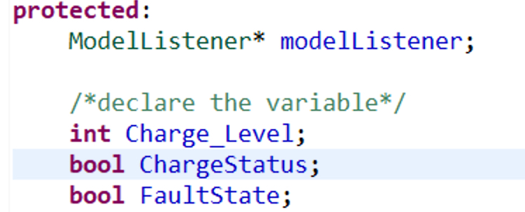

In model.cpp source, first include the main.h and cmsis_os2 header fike as following:

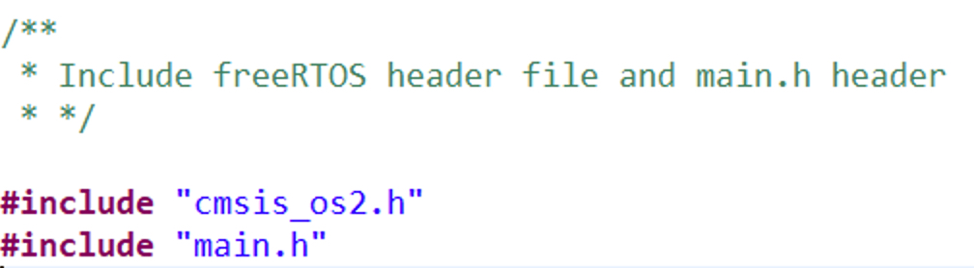
Next, declare the queues of the RTOS as external as following:

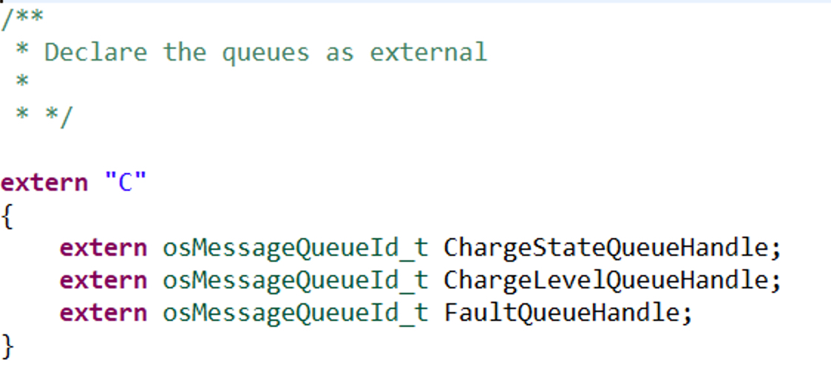
Note: you need to use extern “C” since the source file is C++ and freeRTOS uses C.

In model::Tick function:
First handle the chargeLevel Queue as following:

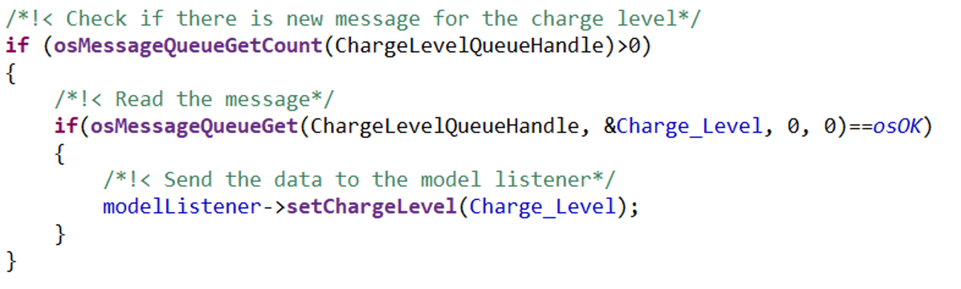
Check if there is new data, if there is, get the new data by storing into charge level variable and push it to setChargeLevel function.

With similar steps to charge level queue handler, the handle of charge status as following:

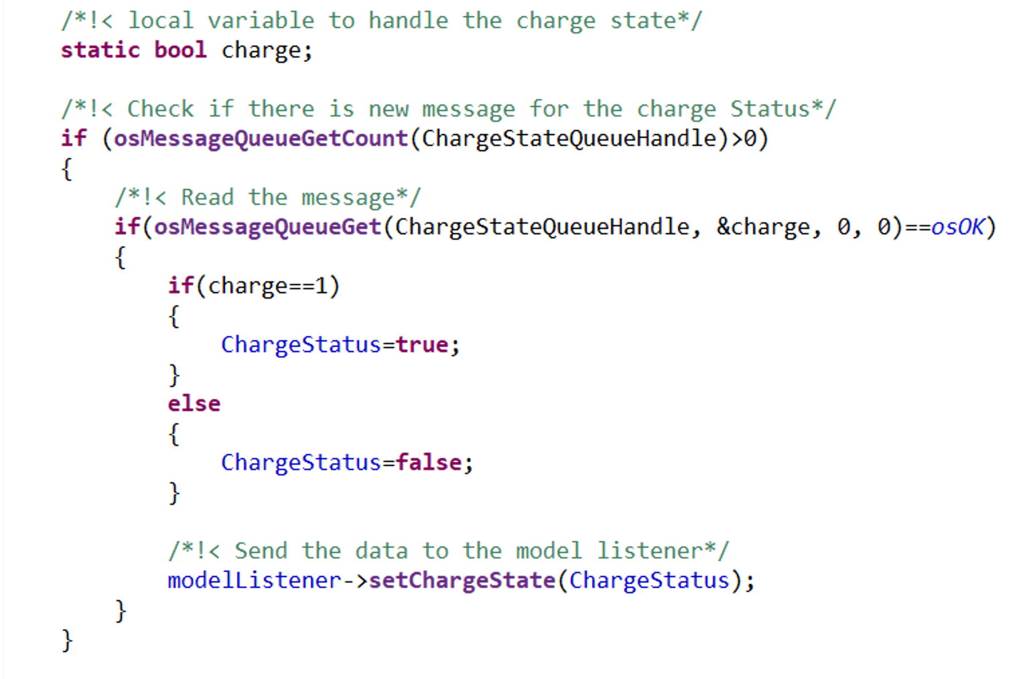
First, declare local bool variable charge to check if the status is charging or not.
Then check if there is new message, if there is, get the new data, check the status and push the status to setChargeState function.

Similarly, for the fault handler:
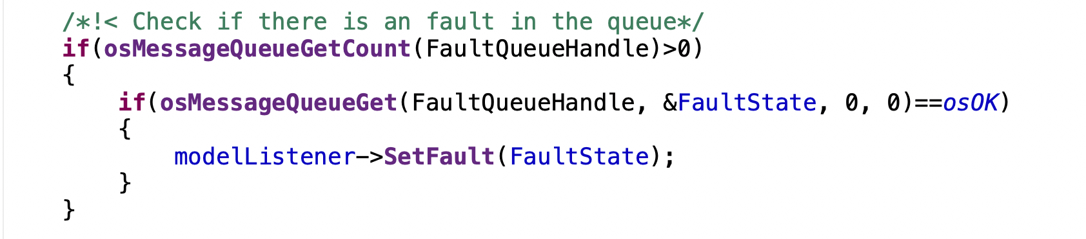

That all for the model.cpp source file.

Next, open Screen1Presenter.cpp and open Screen1Presenter.hpp.
Within the header file, declare the following function as virtual functions:
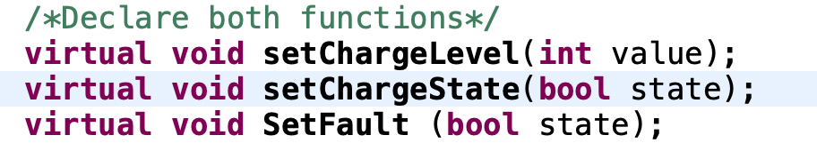
Within Screen1Presenter.cpp, declare the following functions:

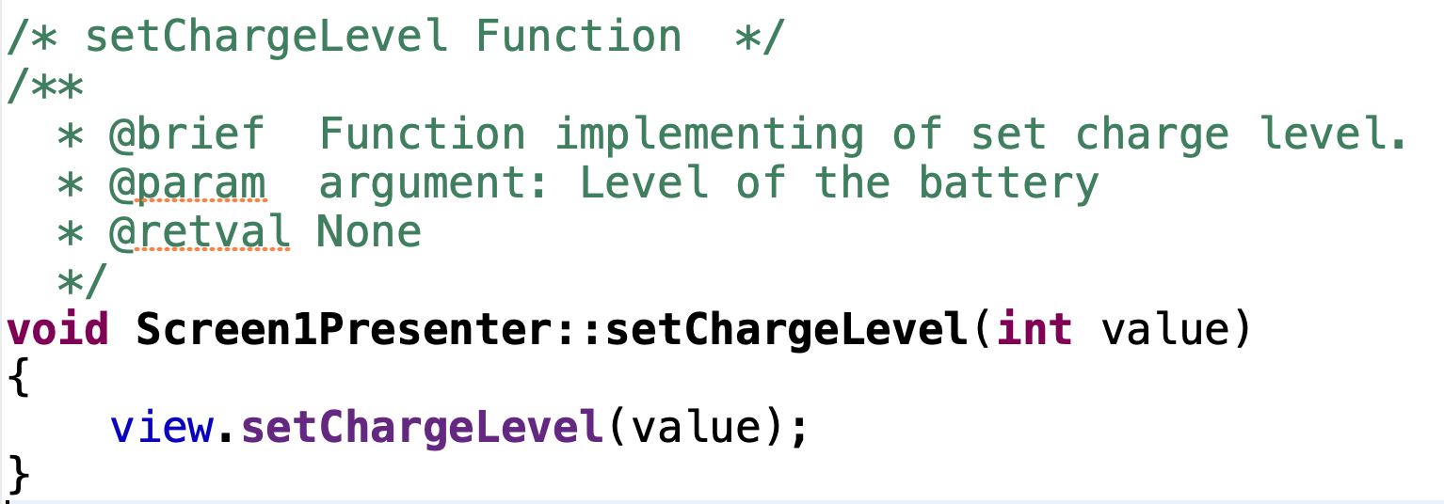
The function shall take the value of charge level and push it again to setChargeLevel function.

In similar manner, for setChargeState and fault:

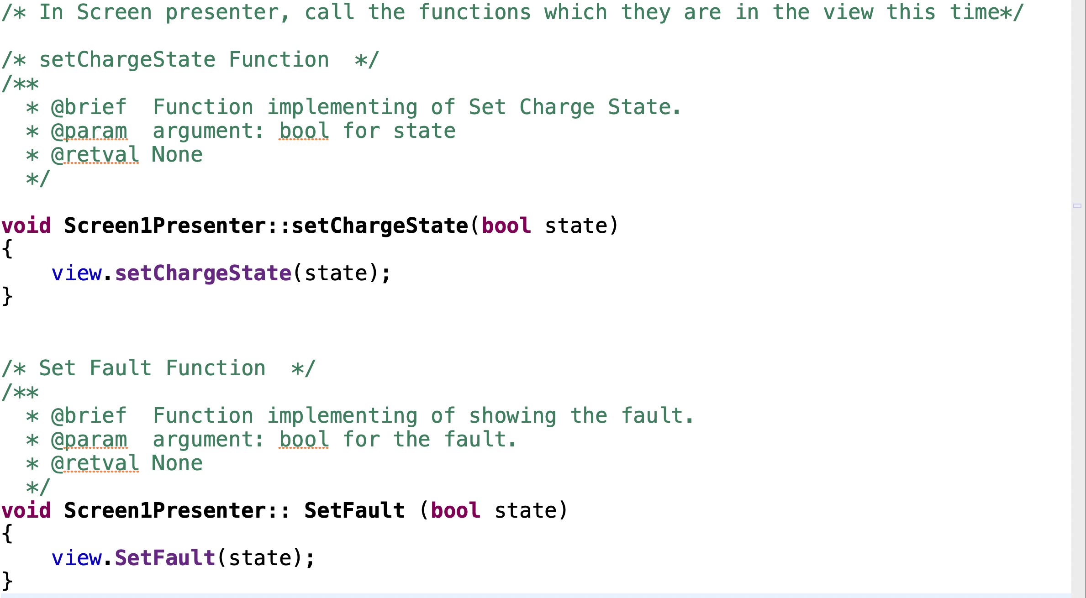

Next, open screen1view.cpp source file then open screen1view.hpp using similar steps for modelListener.hpp header and declare the following functions within the public and as virtual:

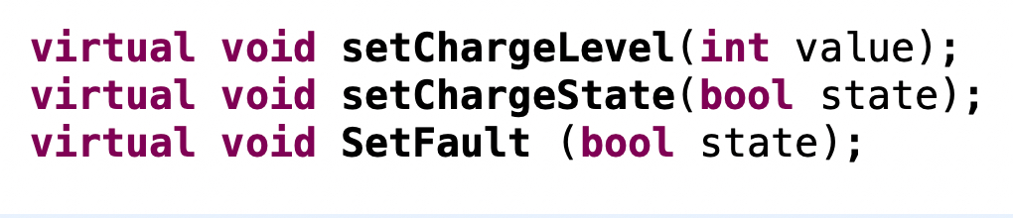

In the source file of Screen1View.cpp, declare the following variable to handle the fault state:

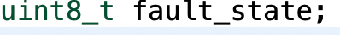

Next, the setCharge level function:

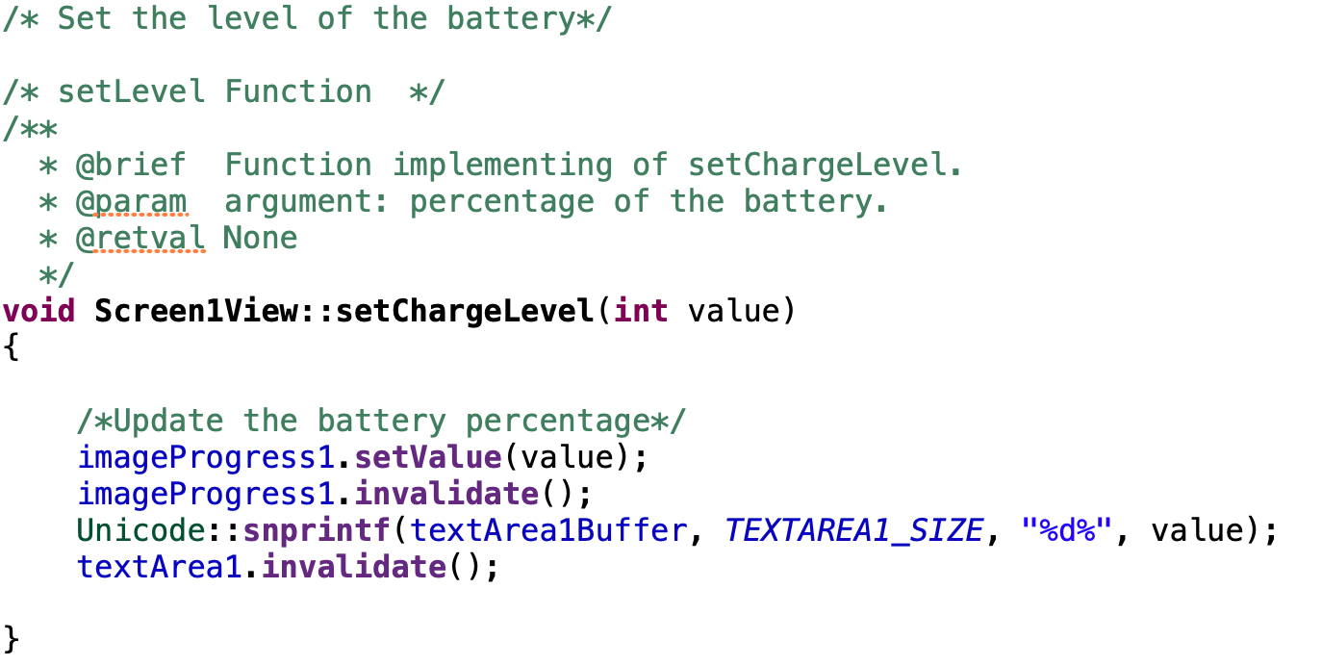
This function takes the value of the charge level as argument. Within the function, update the image progress value by calling the imageProgressName.setValue function (imageProgress1 in this case) followed by invalidate it to make the changes immediate.

For the textual feedback, by using Unicode::snprintf function to update the text area.
The function requires the textnameBuffer followed by the size variable to be printed which is similar to the standard printf function offered in C language. Also, invalidate the text area so that the changes shall appear immediately.

For setting the charge status, declare the following
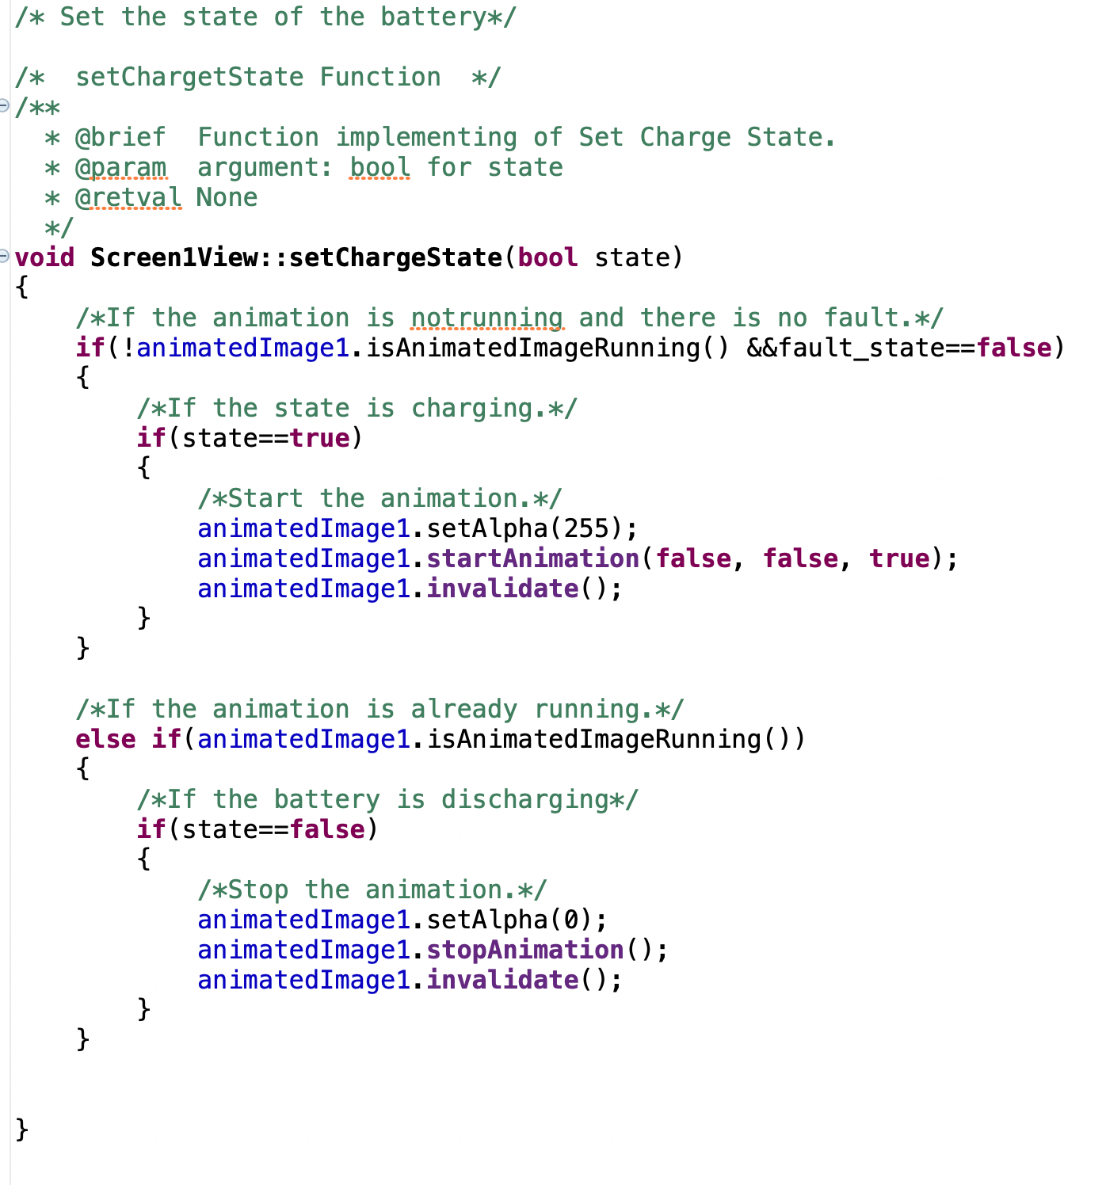

The function first check if the animation is not running and there is no fault. If the statement is correct which means the animation is not running and there is not fault, check the state of the charge, if it is charging, set the animated image alpha to 255 so it will be visible, start the animation with the following parameters:
- First parameter to false to indicate to start in right order not reversed order.
- Second parameter to false to indicate to start the animation from scratch.
- Third parameter to true to loop the animation over and over.
Invalidate the animation image to reflect the changes immediately.

Next, in case the animation is running, check the state if it is discharging, if it is discharging, set the alpha to 0 to make the animation invisible, stop the animation and then invalidate for immediately apply the changes.

Finally, run the project on your Riverdi 10.1 by clicking on run button:

Thats all for the 10.1” screen.
Next section is for the 7 inch which share almost identical steps.

7. Firmware Development for Riverdi 7:

Now for the firmware of Riverdi 7 which is acting as battery emulator.
Open fdcan.c source file. Within USER CODE BEGIN 0, declare the following variable as external since this variable from freeRTOS source file where the data is being transmitted iver CAN-FD Bus:
CAN-FD filter configuration and initialization:
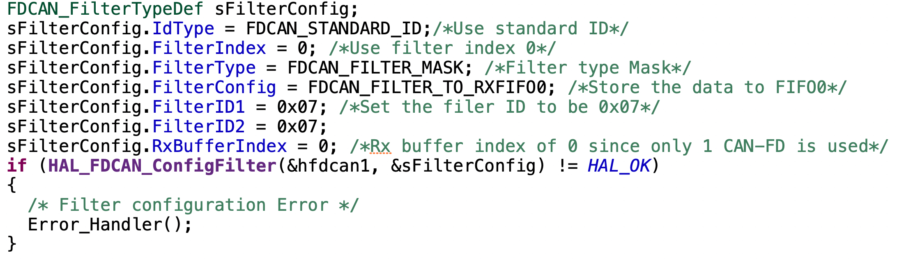
Start CAN-FD and enable notification as following:
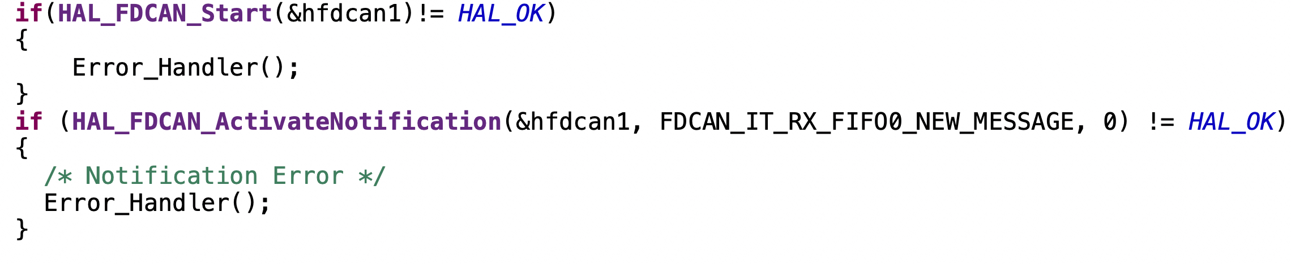
Declare the TxHeader to transmit the data from Riverdi 7 to Riverdi 10.1 as following:

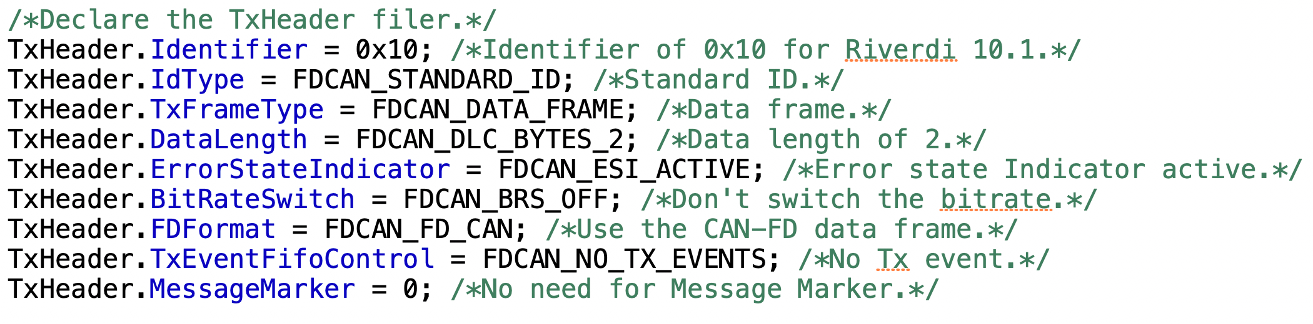
Notice that the Identifier is 0x10 which is for Riverdi 10.1 display where the filter is configured to accept data from 0x10 node only.
Next, freertos.c source file, declare the fdcan handler as external as following:
Declare the following CAN-FD TX and RX header with TxData array of 2 with variable type of uint8_t. This variable shall hold the state of the charge and battery to be transmitted over CAN-FD to Riverdi 10.1.
The RxHeader here is to receive data from Riverdi 101. (left to the user).
Next, declare the following variable which is used to emulate the battery being charged/discharged as following:
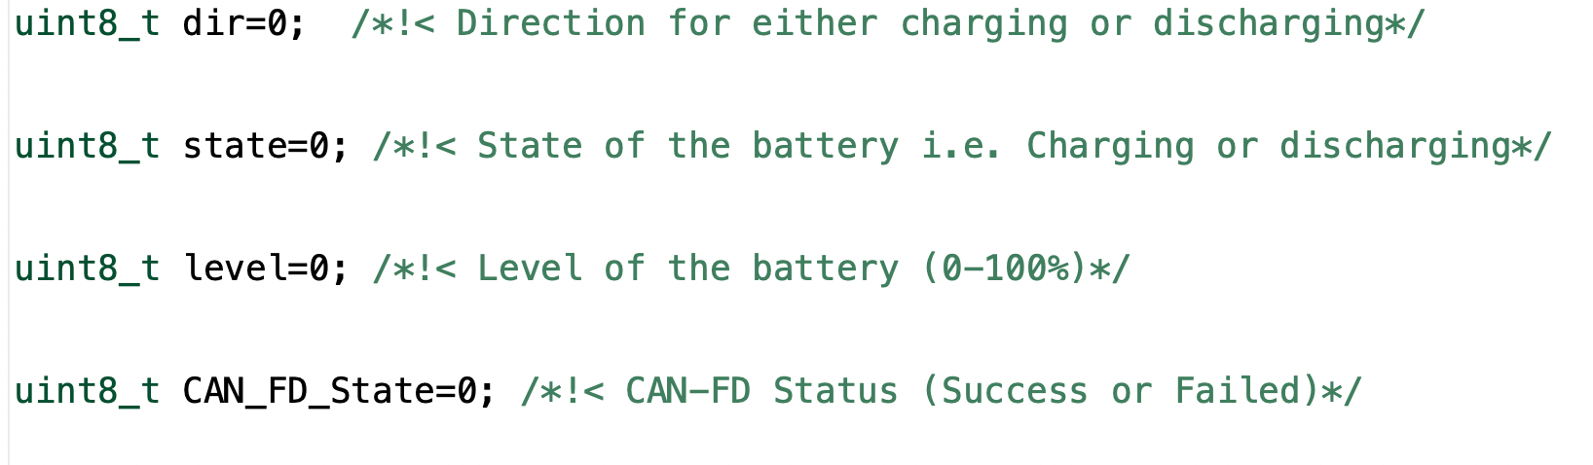
Next, in StartBatteryController task within the infinite for loop:

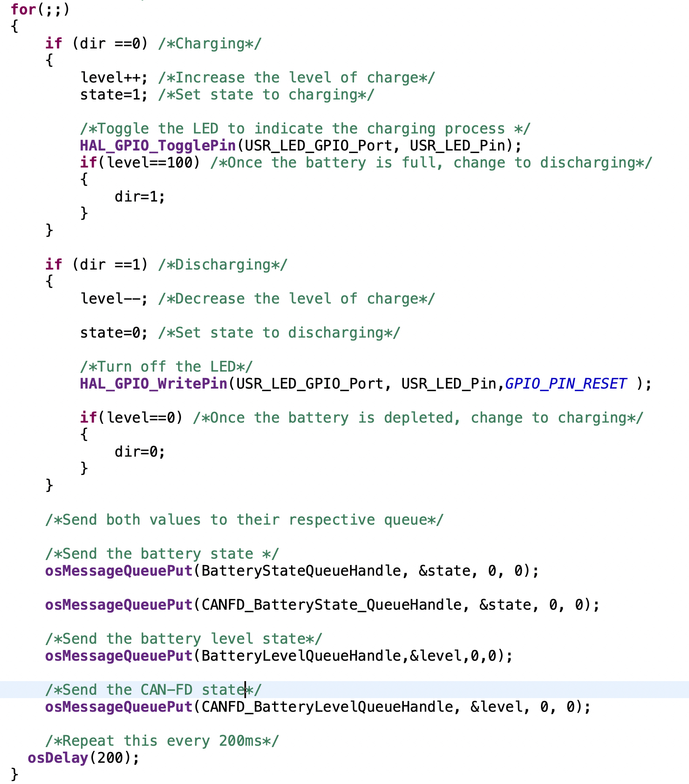
Firs, check if the dir is 0 which means here the battery is charging, if it is, increment the level by 1, set the state to 1 to indicate that the battery is charging, toggle user LED as LED blinking near the charging port of the EV. Once the level reached 100, change the dir variable to 1.
In case the dir is 1, set the state to 0 to indicate the battery is discharging, decrement the level by 1 and set the LED state to low (turn off the LED). Once the level reached 0, set the dir to 0 to indicate the charging process.
After the checking process, using queues, send the battery state to Battery state and CAN-FD battery state. In similar manner, also for battery level. This process shall be repeated each 200ms by using osDelay 0f 200. Here, osDelay is used to suspend the task until the amount of delay has been passed. Using HAL_Delay will force task to be delayed by that amount and wasting CPU for doing nothing but waiting for the delay to finish.
Next for CANFD task:
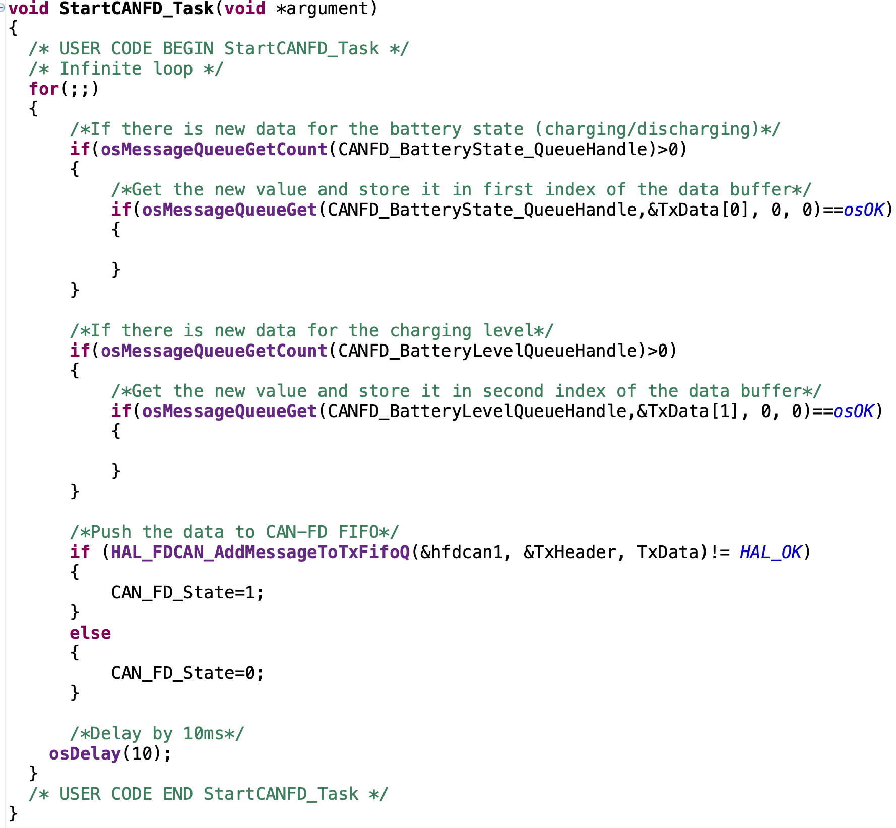
Within the infinite for loop, Check if there is new data in the CANFD queue for both batter state and level. If there is new value, store the batter state as first element of the array of TxData and state as second element of TxData array.
Then, send the data over CAN-FD bus and check if the data transmission is correct, if it, set CAN_FD_State to 0 to indicate there is no error, if not, set it to 1 to indicate there is an error.

Next, from model.cpp source file, open model.hpp header file using the same procedure explained in Riverdi 10.1.
In the header file, declare the following variables within protected section:
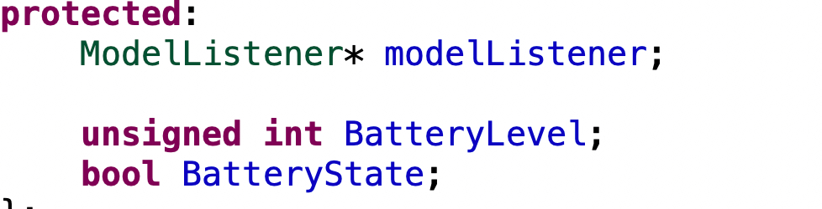

In modelListener.hpp header file, declare the following functions as virtual:
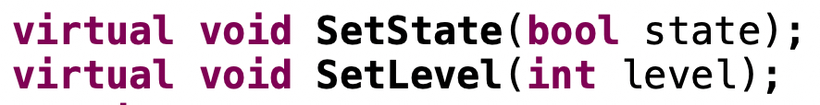

In Model.cpp source, within Model::Tick function:
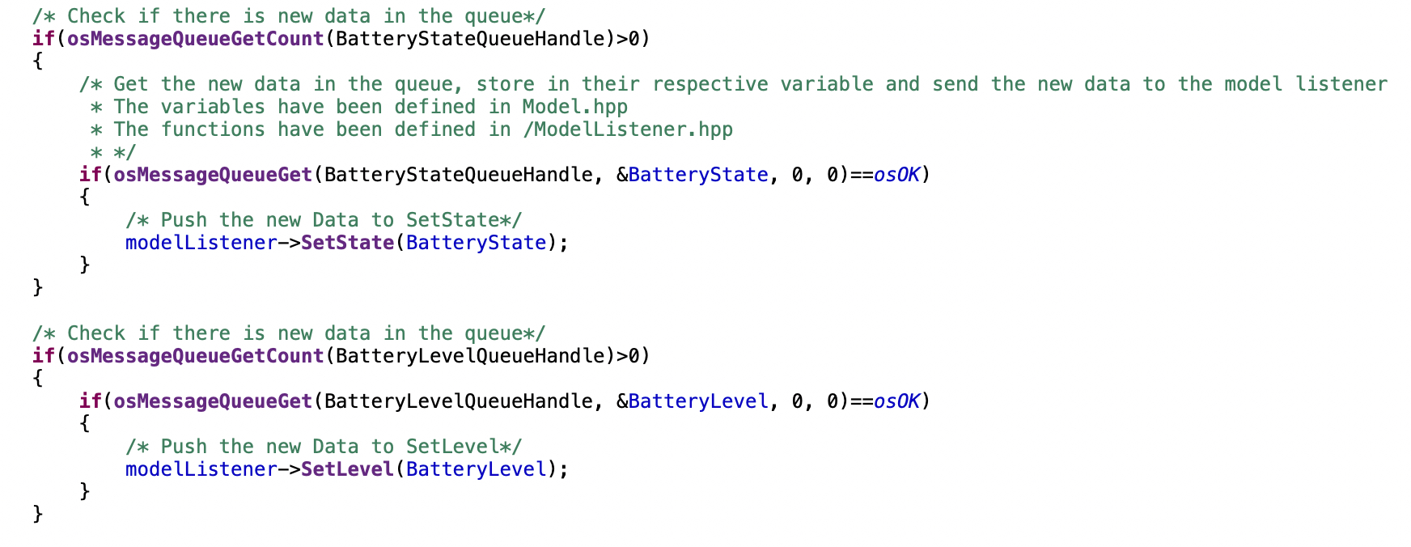
Check if there is new message in BatteryState and BatteryLevel queues, if there is new data, get the new data and store it to it’s respective variable (BatterState and BatteryLevel respectively). After getting the data, push the data to their respective functions.
Next, in Screen1Presenter.hpp and Screen1View.hpp, declare the following two functions:

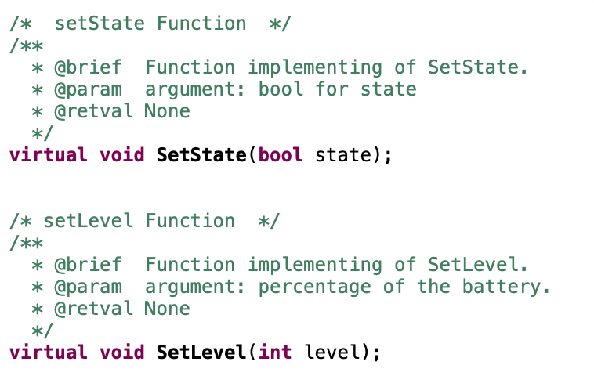

Screen1Presenter.cpp functions implementation:

For screen1view.cpp functions implementation:

First declare this external variable which is about CANFD_State:

For setState function:
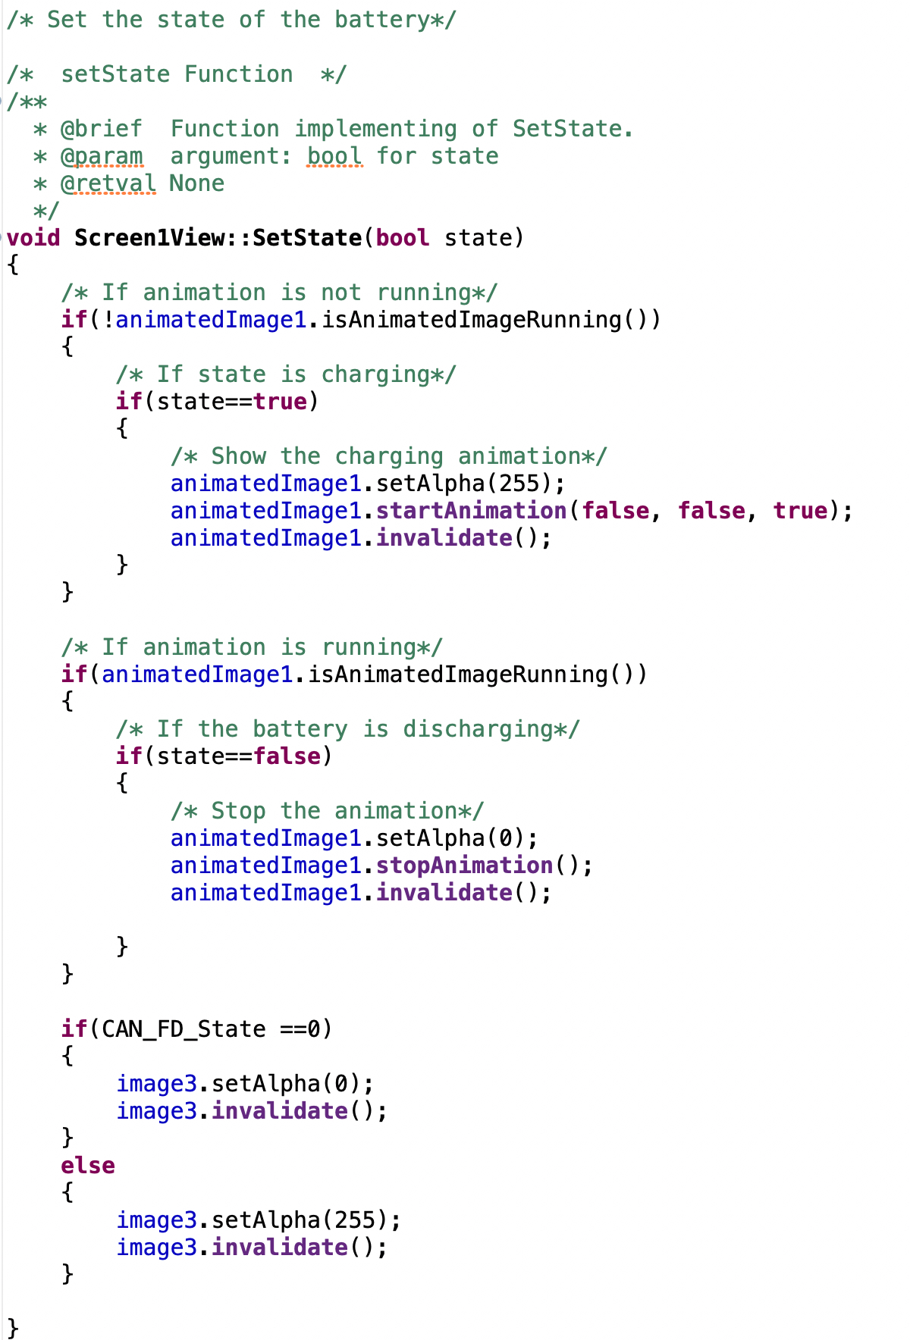
First, the function checks if the animation is not running, if it is not, check the state, if it charging, play the animation with same parameters as mentioned in Riverdi 10.1 section.
In case it is already running, check the state, if it discharging, stop the animation.
Also, the function shall check the CAN-FD has an error or not, if there is an error, it shall display the error message, if not, no need to display the image.

For set the charge level function:
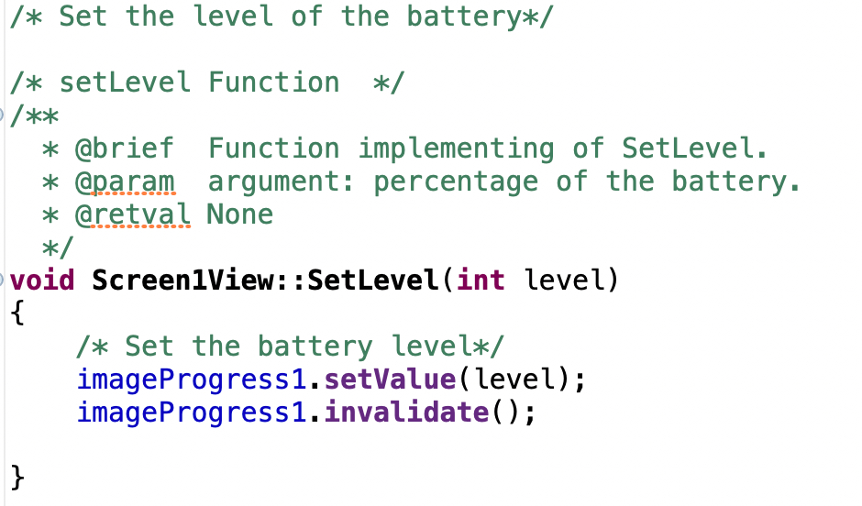
The function will set the level of image progress then invalidate for immediate effect.

Thats all for the firmware development for Riverdi 7.
Finally, run the project on your Riverdi 7 by clicking on run button:

8. Riverdi Display Connections:

The connection as following

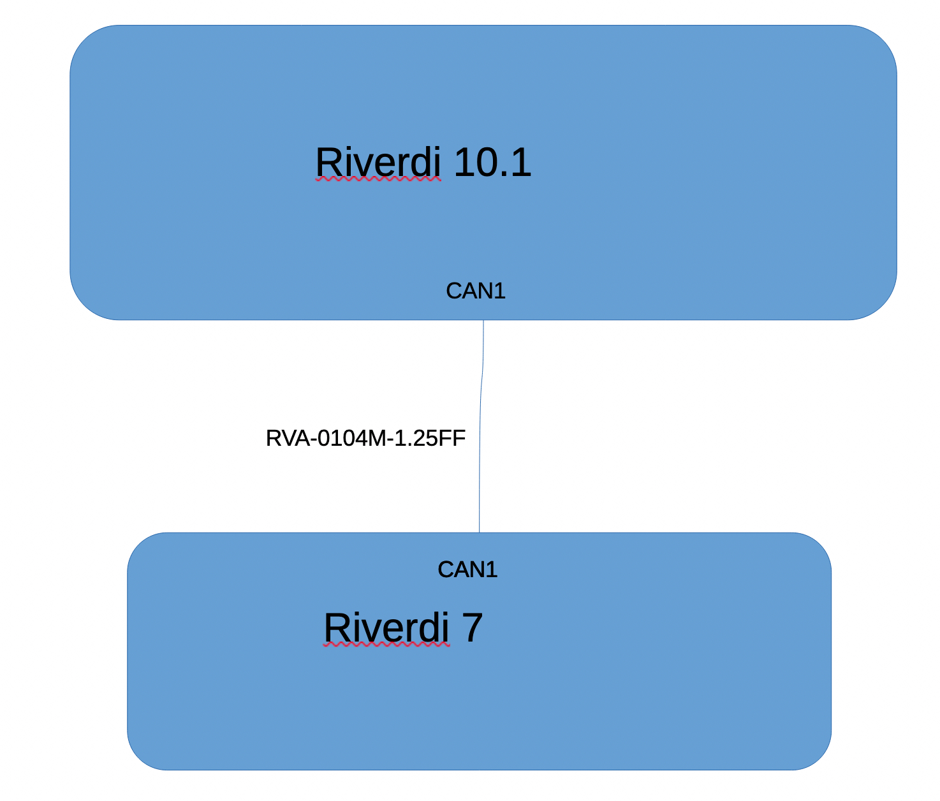
Connect the two displays using CAN1 connector on both screen using RVA-0104M-1.25FF cable.
Also, provide power to one display only either the 10.1 or 7 since one display can provide power to the other display over the cable.

8. Results:
Youtube video can be found here.

